INSIGHT CREATION WORKFLOW
-STEPS TO SOLVING A BUSINESS PROBLEM THROUGH DATA ANALYSIS
STEP 1 : WHAT IS THE BUSINESS PROBLEM?
(DETAIL : From the business case, always try to get a clear picture of what your main business problem is? If you have multiple problems, list them one by one. Clarity is the KEY)

Meldo is trying to figure out whether its coupon marketing campaign is working, which coupon type is working, and how its consumers are using them.

STEP 2: GET DATA & PREPARATION :
GET DATA / INITIAL LOOK AT DATA/ UNDERSTAND QUALITY & IDENTIFY POSSIBLE DEPENDENT AND INDEPENDENT VARIABLES.
- List the Variables of Interest(of Good quality only).
(DETAIL : When you get the Data, always take a first look at the quality of data. For a simple check, you can use the “Filter” option in Microsoft Excel to understand the range of values for each column.
Subsequently, you can use a Statistical tool like SPSS, to ensure critical data parameters as missing values, outliers etc are checked and corrected.
Only a good clean dataset should be used for data analysis. The data you are using in this class are clean good quality data )

Variables of interest
StoreID : Unique identifier for store
HealthyStore : Type of Store
Store Size : Size of store based on store area
StoreLayout : Design of the Store
CustomerID : Loyalty membership card number
Gender : Gender details of the consumer
Who Shopping For : Details on who the consumer is shopping for
Vegetarian : Consumer preference for vegetarian food
Shopping Style : How and when the shopping is done
Coupon User : What type of coupon is used by consumer
Week : Week of usage of coupon
CouponValue : Discount Percentage in the coupon
Amount Spent : Amount spent in store by the consumer for their purchases.

- Mark them as Independent Variable (IV) or Dependent Variable (DV)
(DETAIL : In the Data, there will be multiple data variables. Based on your business problem, you need to identify which ones can be considered as dependent(outcome) variables and which ones are Independent variables. For example, if your business problem is “Which strategy helped the Sales”? Your main DV is Sales and IV is Type of Strategy)

- Dependent variable (DV): Amount Spent
- Independent variables (IV): StoreID, HealthyStore, Store Size, StoreLayout, CustomerID, Gender, Who Shopping For, Vegetarian, Week, CouponValue, Coupon User, Shopping Style

- Possible 5 Interesting Questions connecting the above variables.
o (DETAIL : This is one of the important steps in the Insight Creation Process. Based on the business case, you start thinking of questions to ask so that you reach your final insights. For example, you may start asking “Which strategy influenced Sales the Most”. This question will give you one insight.
o The next big step is to “Drill into this data further”- For example, you can now ask “Does the effect of Strategy Type on Sales change with respect to Location?” . The answer to this question will help us get another deeper insight into the problem.
o In this sequence, keep asking questions, till you have enough insights to solve your business case.
o “DEEPER DRILLING IS THE KEY” )

- Is there a relationship between the amount spent and the coupon used?
- Is there a relationship between amount spent and shopping style?
- How does the consumer’s shopping style affect the relationship between the amount spent and the coupon user?
- Is who you are shopping for impact the relationship between how much you spend and coupon used?
- Is there a relationship between the amount spent and the coupon value?
- Does shopping style affect the relationship between amount spent and coupon value?
- Does who customers shop for impact how much they spend per week?

STEP 3: EXPLORE DATA TO SEE ASSOCIATIONS / TRENDS
(DETAIL : For each of the questions, you have made above, Use the Business Intelligence Tool (IBM Cognos Analytics) to gain insights. An Insight is a clue or piece of information you derive from analysis of data.
In IBM Cognos, you can use the “EXPLORE” feature and make EXPLORE cards for each question. Each card can help you with an associated insight.
Please note that, sometimes, you may find that your question maynot give you any good info. You can always change your question or drill in further to a question, which may be giving you interesting insights. This is a Dynamic process and you keep adding in as many cards as you want)

Question 1 : Is there a relationship between the amount spent and the coupon used?
Insight 1 : 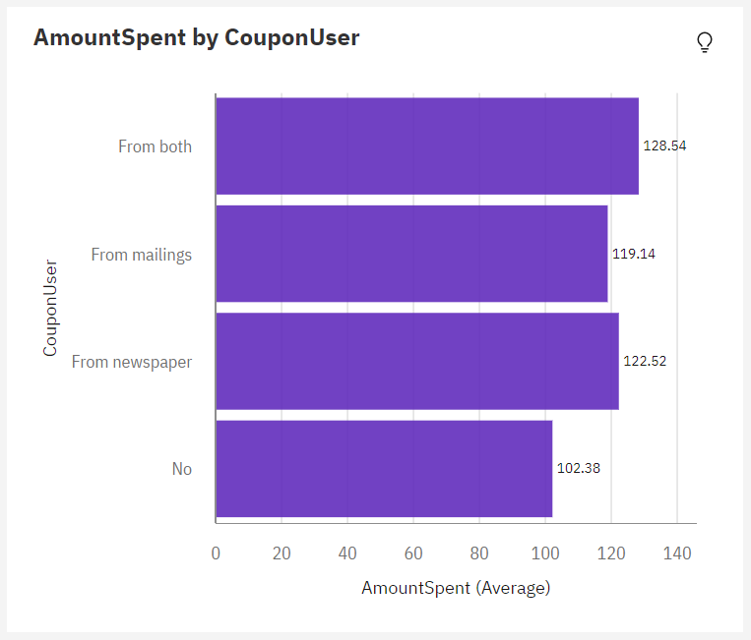
- The average amount spent for all coupon users is 118.5
- Relative to the average, the highest value (128.54) when both coupon types are used (mailings and newspaper) is considered to be high
- The lowest value, 102.38, is considered to be low compared to the average, when the customer does not use a coupon
- Customers spend the most money when they use both types of coupons
- Customers who use newspaper coupons spend more than customers who use mailings (122.52>119.14)
- The most commonly used coupon type is mailings (mailings is the most common value, occurring 468 times, 31.3% of the total)

Question2: Is there a relationship between amount spent and shopping style?
Insight 2: 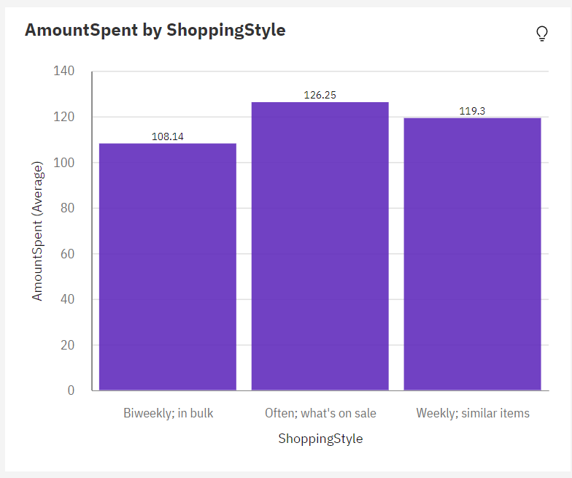
- Most common shopping style among consumers is to shop weekly and buy similar items (908 times, 60.7%)
- Consumers spend the least amount of money when they shop biweekly and in bulk (108.1) and the highest when they buy often and what's on sale (126.3)
- When consumers shop weekly and purchase similar items, they spend on average 119.3, lower than if they shopped often and purchased items on sale.

Question 3: How does the consumer’s shopping style affect the relationship between the amount spent and the coupon user?
Insight 3: 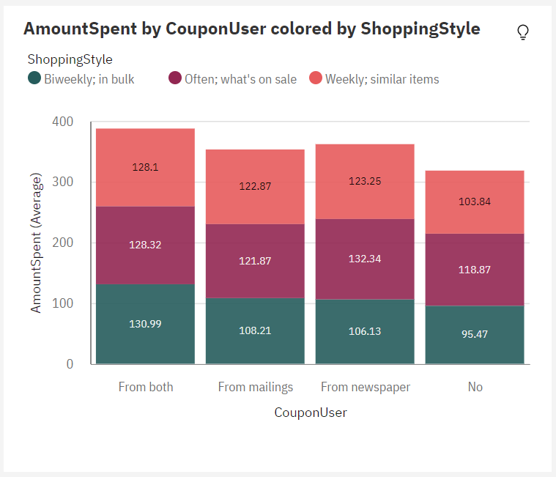
- Weekly shopping is the most average shopping style at 60.7% of the total. The amount being spent by consumers is lower when shopping style is done biweekly in bulk.
- The most valuable form of coupons being used come from mailings, occurring 468 times, 60.7% of the total.
- The average values of the amount spent range from 95.47 to 132.3.
- When no coupons are being used, the amount spent is usually low.
- When no coupons are being used and the customer is buying in bulk biweekly, the amount spent is usually low

Question 4: Is who you are shopping for impact the relationship between how much you spend and coupon used?
Insight 4: 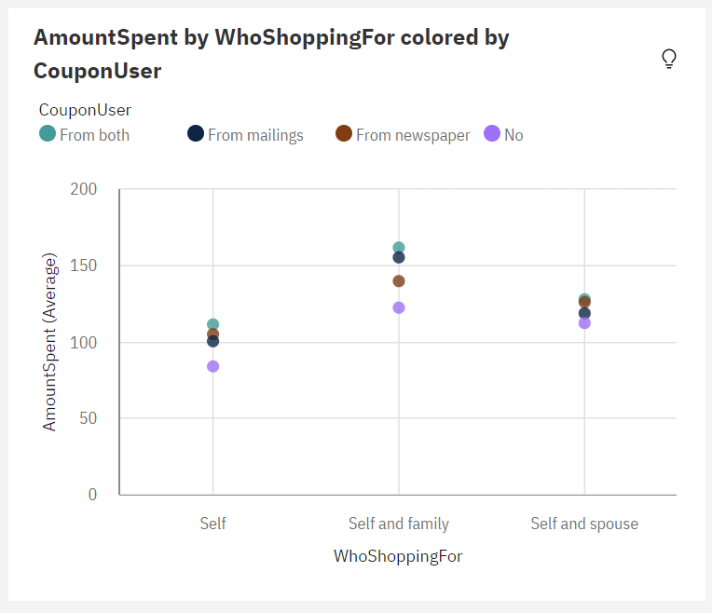
- The average amount of spending across all values of coupon users and who the customer is shopping for is 118.5.
- The most common values for who customers shop for are “self” (40.6%) and “self and spouse” (36.1%), occurring over a thousand times
- Who a customer shops for weakly affects amount spent (10%)
- The most common value of coupon user is “mailings”, occurring 468 times, which is 31.3% of the total
- Amount spent is unusually high when the customer shops for “self and family”
- Amount spent is unusually low when the customer does not use a coupon
- The amount spent is highest when customers use both coupons

Question 5: Is there a relationship between the amount spent and the coupon value?

Insight 5: 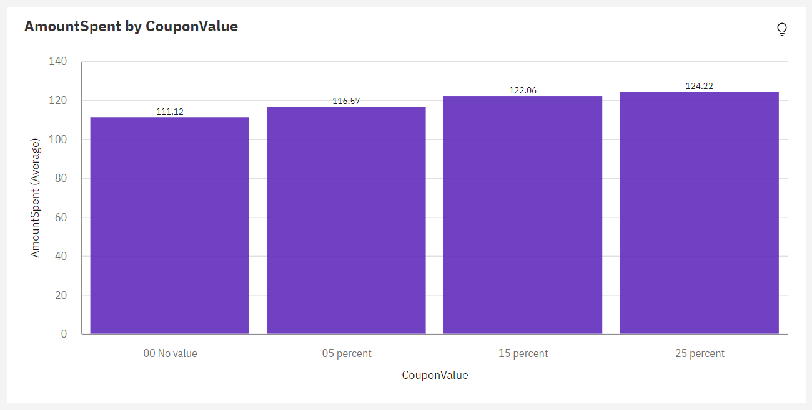
- Over all values of CouponValue, average amount spent is 118.5
- Lowest average amount spent is 111.1 when there is no coupon value (00)
- Highest average amount spent is 124.5 when coupon value is 25%

Question 6: Does shopping style affect the relationship between amount spent and coupon value?
Insight 6: 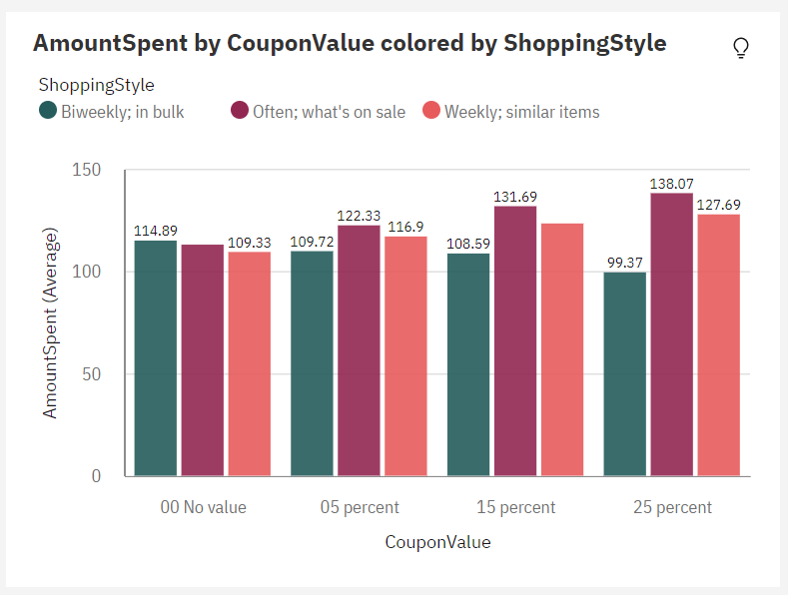
- Over all values of coupon value and shopping style, the average of amount spent was 118.5
- Lowest average amount spent was when shoppers shopped bi weekly and in bulk, and used a 25% off coupon
- Highest average amount spent was when customers bought often and what was on sale, and used a 25% off coupon
- The most common value of shopping style is to shop weekly and buy similar items (908 items, 60.7% of total)

Question 7: Does who customers shop for impact how much they spend per week?

Insight 7: 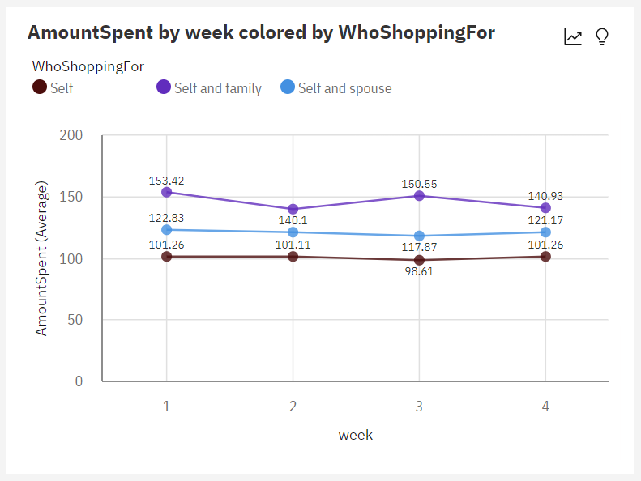

- For amount spent, the most significant values of whoshoppingfor are “self and spouse” and “self”, whose values add up to over 126 thousand, or 71.3% of the total
- Over the span of 4 weeks, customers who shop for “self and family” spend the most on average, followed by “self and spouse”, and then “self”
- Average spending is highest during the first week when customers shop for “self and family”

STEP 4: DECIDE ON THE FINAL VARIABLES FOR FURTHER ANALYSIS . REFINE DATA if Required.
(DETAIL : STEP 4 is always not necessary. If you would like to add any variables to your data or make any calculated columns in your data after initial Step of Exploration, you can do that and then proceed with further analysis.
In examples or submissions we are doing in class, you can do this Step if you would like to but not necessary)

N/A

STEP 5: WITH APRIORI HYPOTHESES, RUN ANALYSES AND MAKE PREDICTIONS.
(DETAIL : In STEP 3, we explored the data and found relevant insights. Now, we want to make sure that these findings are statistically valid as well.
From your main exploration insights, you can list down 2 main hypotheses which you think is the most important. (You can write as many hypotheses as you deem necessary). For example, you can list that “Type of Strategy increases Sales” or “Sales is higher for Males than Females for a certain Strategy”.
Basically, what we are trying to do in this step, is to ensure your main findings are statistically correct. In IBM Cognos Analytics, there is a “Driver Analysis” feature, which does statistical tests using artificial intelligence. You can run Driver Analysis and see whether your Hypotheses and Main insights are correct. You can refer to the Decision Tree Diagram for reference as well)

List 2 Main Hypotheses for causal prediction:

- Giving more coupons with higher values (25%) to customers will increase sales
- Targeting family households and distributing more coupons to them will increase sales

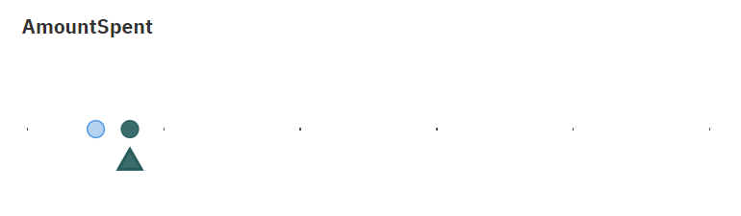

- WhoShoppingFor, CouponUser, CouponValue, and ShoppingStyle predict AmountSpent with a strength of 15.5%
- WhoShoppingFor is the most significant predictor of AmountSpent being four times better than any other field
- WhoShoppingFor is a predictor of amount spent (10%)

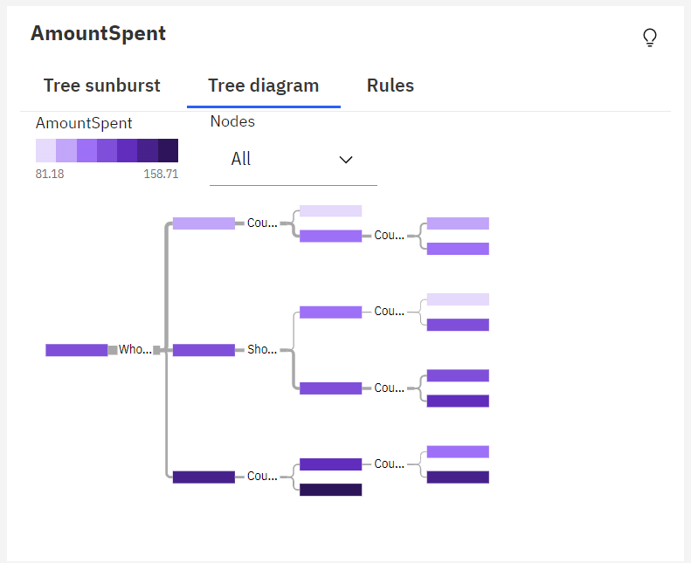

Average Amount Spent
Average amount spent= 118.5
Standard deviation= 55.2
Total= 1,496 (100%)

WhoShoppingFor= Self
Average amount spent= 100.56
Standard deviation= 40.97
Total= 608 (41%)

CouponUser= No
Average amount spent= 84.13
Standard deviation= 35.47
Total= 148 (10%)
CouponUser= From Newspaper, From mailings, From both
Average amount spent= 105.85
Standard deviation= 41.25
Total= 460 (31%)

CouponValue= 05 percent, 00 no value
Average amount spent= 97.82
Standard deviation= 36.83
Total= 230 (15%)
CouponValue= 25 percent, 15 percent
Average amount spent= 113.87
Standard deviation= 43.86
Total= 230 (15%)

WhoShoppingFor= Self and spouse
Average amount spent= 120.8
Standard deviation= 49.76
Total= 540 (36%)
ShoppingStyle= biweekly; in bulk
Average amount spent= 107.79
Standard deviation= 106.16
Total= 104 (7%)
CouponValue= 25 percent
Average amount spent= 81.18
Standard deviation= 108.5
Total= 26 (2%)
CouponValue= 05 percent, 00 No value, 15 percent
Average amount spent= 116.66
Standard deviation= 104.57
Total= 78 (5%)
ShoppingStyle= Often; what’s on sale, Weekly; similar items
Average amount spent= 123.91
Standard deviation= 18.67
Total= 436 (29%)
CouponValue= 05 percent, 00 No value
Average amount spent= 117.03
Standard deviation= 16.12
Total= 218 (15%)
CouponValue= 25 percent, 15 percent
Average amount spent= 130.79
Standard deviation= 18.55
Total= 218 (15%)

WhoShoppingFor= Self and Family
Average amount spent= 146.25
Standard deviation= 70.72
Total= 348 (23%)
CouponUser= From newspaper, No
Average amount spent= 130.92
Standard deviation= 63.84
Total= 156 (10%)
CouponValue= 00 No value
Average amount spent= 109.49
Standard deviation= 57.71
Total= 39 (3%)
CoupnValue= 05 percent, 25 percent, 15 percent
Average amount spent= 138.06
Standard deviation= 64.42
Total= 117 (8%)
CouponUser= From mailings, From both
Average amount spent= 158.71
Standard deviation= 73.68
Total= 192 (13%)

FIND THE PREDICTION INSIGHTS
(DETAIL : Consolidate your main findings from Step5)

The average amount spent by consumers is 118.5. Consumers mostly shop for just themselves and spend the least amount of money on average (100.56). Customers who shop for just themselves use all kinds of coupons and various coupon values. Customers spend the most money on average when shopping for themselves and their families (146.25). Customers who shop for their spouses spend considerably more than if they shopped just for themselves, spending on average 120.8 (20.24 higher). Customers shopping for themselves and their families use mainly mailing coupons or both and use coupon values of 5%, 25%, and 15%.

STEP 6 : CHECK WHETHER YOUR ANALYSIS ADDRESSES THE SOLUTION TO THE BUSINESS PROBLEM.
(DETAIL : Consolidate all your FINDINGS Across Exploration in STEP 3 and Hypotheses Check in Step 5 and list them as insights. Check and describe whether this is good to solve your business problem.
If not, you may want to go back and rework on Step 3 and 5 again!!!)
Customers spend the most on average when they use both types of coupons (128.54), and the most commonly used coupon is mailings (468 times, 31.1%). This information is essential because it tells us which coupon type gets customers to spend the most and which one customers are actually using most often, which will help assess the campaign's effectiveness. Customers most frequently shop for only themselves (40.6%), but the amount spent is highest when customers spend money for “self and family.” Customers who shop for “self” spend on average 100.56, but when customers shop for “Self and family,” they spend on average 146.25. Knowing the relationship between average spent and who the customer shops for is important for solving the business problem. It tells Meldo who their target market for the campaign should be and who their market currently is. The average amount spent by consumers is 118.5; customers spend the least amount when there is no coupon value (111.1) and spend the most when the coupon value is 25% (124.5). Customers also spend the most when they buy often and what is on sale using a 25% coupon; however, the most common shopping method is to shop weekly and purchase similar items (908 items, 60.7%). When consumers shop weekly and purchase similar items, they spend on average 119.3, lower than if they shopped often and purchased items on sale (126.3). This information is helpful because it tells Meldo which coupon value they should distribute the most based on the average amount customers spend and what type of coupon they should focus their production and distribution costs on.

YOUR MAIN STORY
(DETAIL : Write all your Insights with a logical flow.. Try to write down your main insights in 2-3 regular sentences)
Meldo’s coupon marketing campaign could’ve been more effective. This is because they are targeting the wrong customers– ones that are not spending as much money! Meldo’s most frequent customers are not as profitable, impacting sales and revenue:
- They mainly shop for themselves, spending an average of 100.56
- Shopping weekly and buying similar items, spending an average of 119.3
- The most common coupon used is mailings (468 times, 31.1%)
- These customers use just as much coupon values that are 00 and 05 percent as they are using coupons with values of 15 percent and 25 percent (both 230 items, 15%)
Our findings show that customers who spend the most money are buying for “self and family,” shopping often and what is on sale, using both newspaper and mailings coupons, and are using 25% off coupons. Based on these insights, we suggest:

- Create a family rewards program that gives family households exclusive access to additional store coupons, encouraging them to use coupons more often and spend more
- Create coupons that give discounts on sale items, encouraging customers to shop more often, buy items on sale, and spend more
- Distribute even amounts of mailings and newspaper coupons to encourage customers to use both and spend more
- Distribute higher amounts of coupons with 25% off values than other coupon values, encouraging customers to spend more

