MKTG 460 MID-TERM EXAM
UIC COLLEGE CHOICE: SEGMENTATION STUDY

- 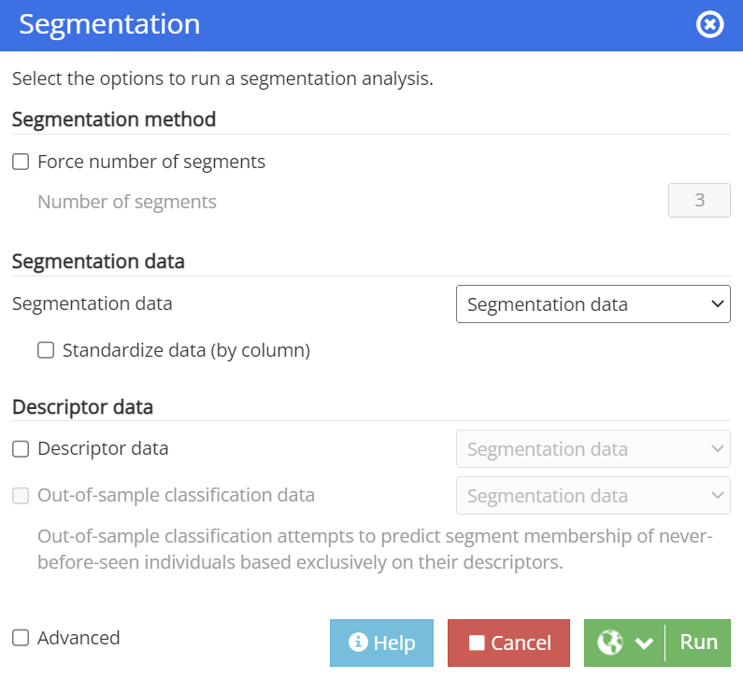

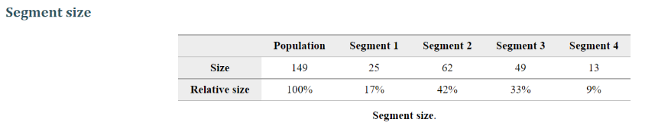
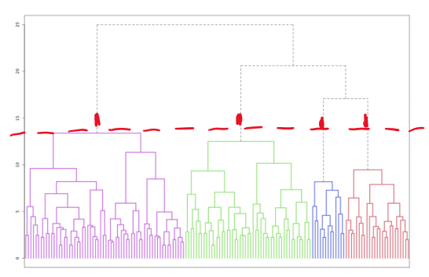

When running the segmentation analysis using the default options in Enginius, the segments identified are four. The total population is 149; the size of segment 1 is 25, the size of segment 2 is 62, the size of segment 3 is 49, and the size of segment 4 is 13.

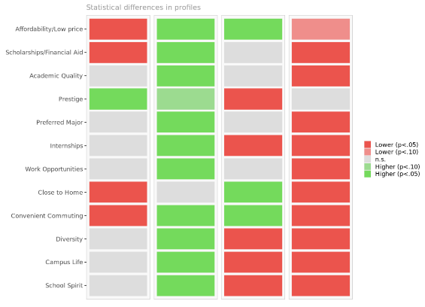
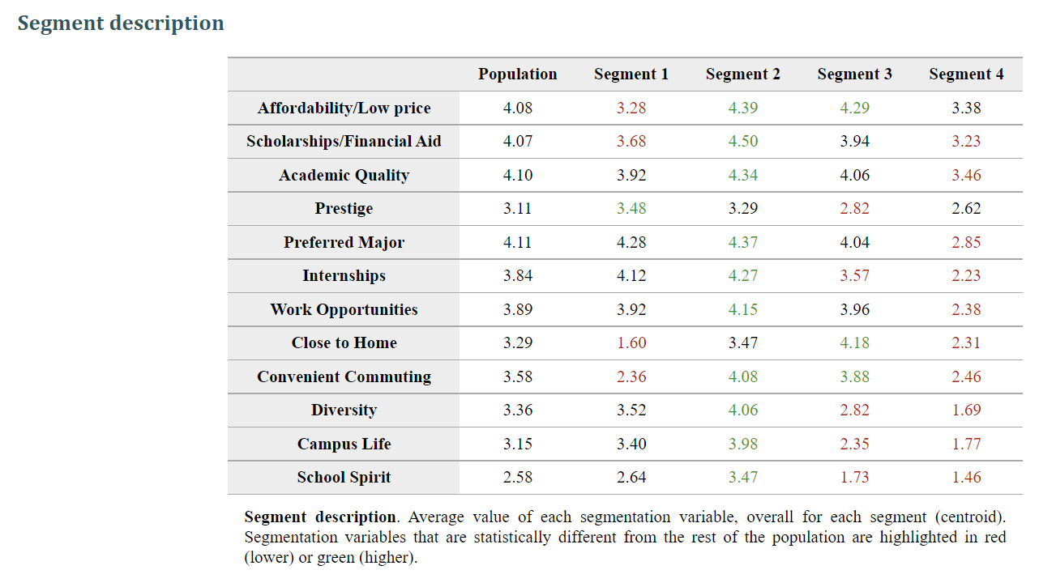
Segment 1 represents individuals who are not price conscious when choosing to attend a university; Affordability/Low Price, Scholarships/Financial Aid, Close to Home, and Convenient Commuting are segmentation variables that are statistically significant below the population on average. This segment is more concerned about the prestige of the school than work opportunities, affordability, and the campus environment. This segment of students looks for a school that will give them social status and appraisal.
Segment 2 differs from segment 1 in that this segment is price-conscious when choosing to attend a university. Segmentation variables Scholarships/Financial Aid, Affordability/Low Price, and Convenient Commuting, all variables related to cost savings, were statistically significant above the population average. Segmentation variables relating to work and career advancements, such as Preferred Majors, Internships, and Work Opportunities, were also statistically significant and above average. Segmentation variables relating to the campus environment, including Diversity, Campus Life, and School Spirit, were statistically significantly above average. This segment of students looks for a school that will give them the full college experience at a lower price.
Segment 3 is very concerned about the location of the school—they value being close to home more than the other factors, the biggest differentiator between the different segments. Segmentation variables that are statistically significant above the mean are Affordability/Low Price, Close to Home, and Convenient Commuting. Segmentation variables statistically significant below the mean are Prestige, Internships, Diversity, Campus Life, and School Spirit. This segment of students looks for a school that is conveniently close to home.
Segment 4 feels indifferent about going to school, with no segmentation variable holding much importance in influencing their decision-making. Segmentation variables statistically significant below the mean are Scholarships/Financial Aid, Academic Quality, Preferred Major, Internships, Work Opportunities, Close to Home, Convenient Commuting, Diversity, Campus Life, and School Spirit. This segment could include people who were pushed to college by friends/family members, considering that they chose to go to UIC.

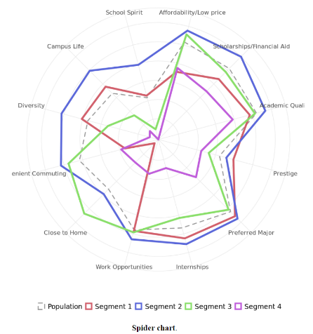
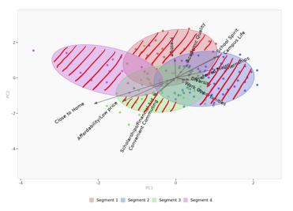

Yes, this solution looks reasonable to me:
While there is some overlap in the segmentation space, there are still clear distinctions; the spider chart also shows differences in shapes between the four segments.
Segment 4 is small, with only 13 students; these students don’t have any factors that they find important when deciding where to go to school. One reason may be that they have other personal reasons that weren’t listed in the survey or that they were forced to go to college. While this segment is such a small number, I think it is essential to include it to distinguish needs-based students versus those who aren’t for better targeting. Based on the segmentation variables, each segment is different enough with their motivations for choosing a school, particularly UIC. Therefore, these segments make sense.

- 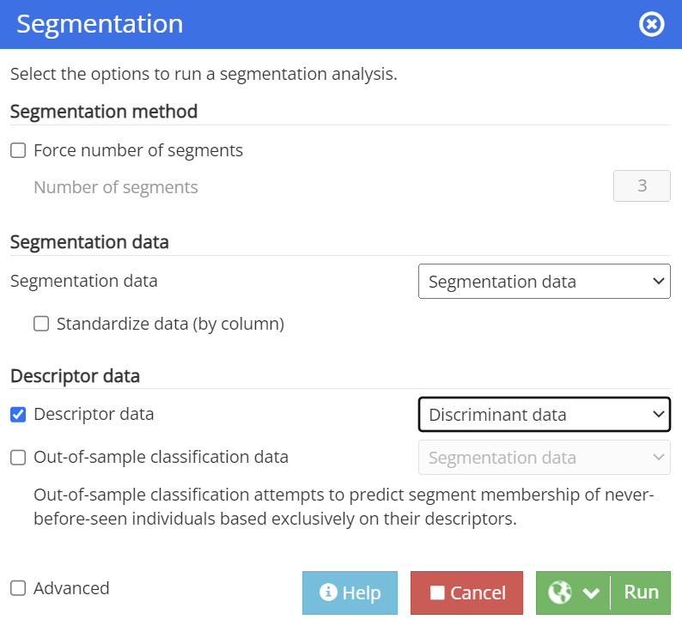

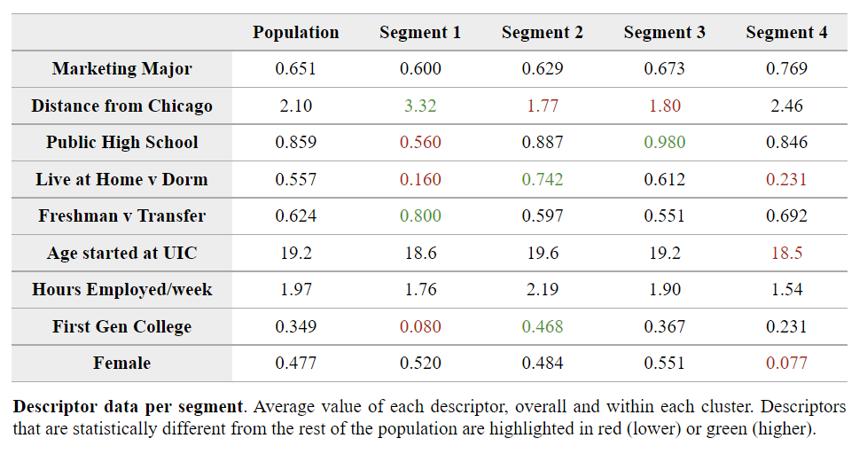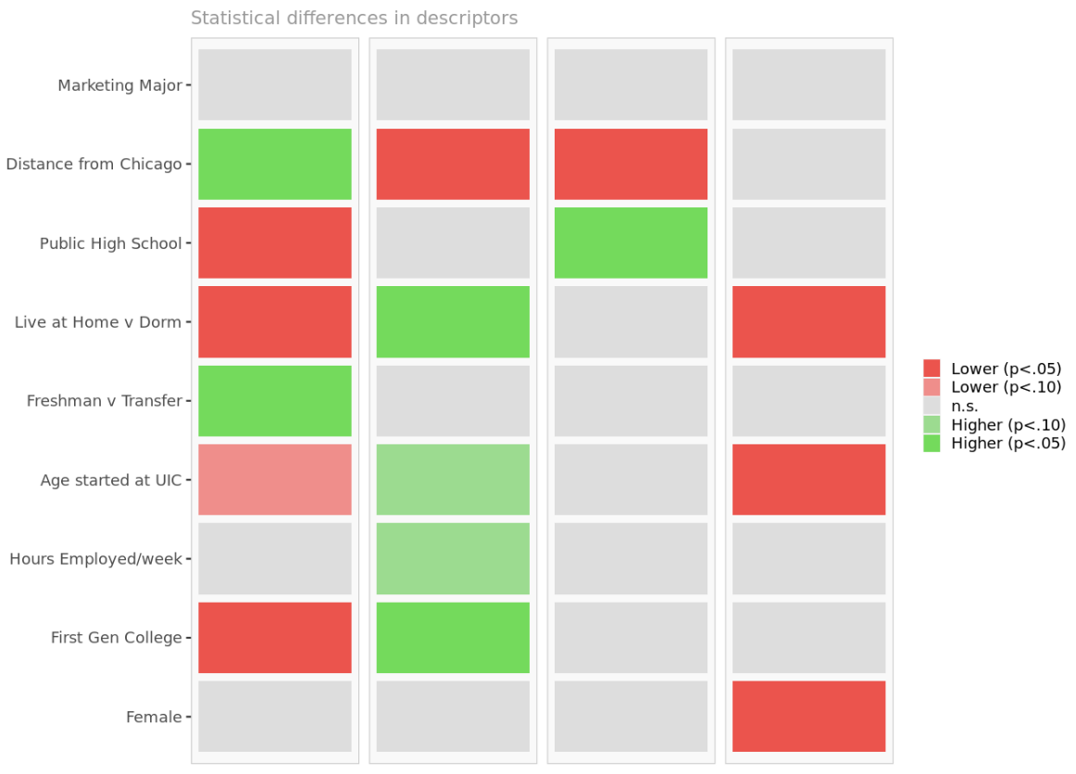
Segment 1. Variables statistically significant above the average are distance from Chicago and freshman v transfer. Variables statistically significant below the average were Public High School, Live at Home v Dorm and First Gen College. This segment consists of students who live farther away from school, are transfers or worked before coming to UIC, come from a private high school, plan to live on campus, and are not first-generation college students. It would make sense that this segment is looking for prestige in a college. These students went to a private school, are likely transferring to look for better schooling options, and come from a family of college graduates—attributes of someone from a higher-income household. UIC Business can offer value to this segment by retaining its accreditation, earning higher school rankings, and keeping a positive brand image.
Segment 2. Variables statistically significant above the average are Live at Home v Dorm and First Gen College. The variable that is statistically significant below the average is Distance from Chicago. This segment includes students who plan to live at home, are first gen college students, and live close to Chicago. This segment includes students who want the complete college experience and those who live close to home. The most significant difference between segments two and three is that segment two students are mostly first-generation. UIC Business can provide value to this segment by offering financial aid and scholarship opportunities specific to first-generation students. UIC Business can also have informational sessions for first-generation students so they are aware of on-campus resources for work and internships.
Segment 3. The variable statistically significant above the average is Public High School; the variable statistically significant below the average is Distance from Chicago. This segment includes students who went to public high schools and live closer to Chicago. This segment lives closer to Chicago and wants to go to a school closer to home with convenient commuting. UIC Business can provide value to these students by offering a UIC Business Commuter Program that gives local students access to commuting assistance and informational sessions (i.e., discuss available commuting options) and give commuters opportunities to interact and connect.
Segment 4. Variables statistically significant below the average are Live at Home v Dorm, Age started at UIC, and Female. This segment consists of students who plan to live on campus, start at UIC at a younger age, and are predominantly male. This segment may feel indecisive or indifferent about college. UIC Business can provide value to these students with guidance through career workshops, UIC Business Q&A sessions, and special counseling for younger students who want to learn more about UIC opportunities, UIC Business majors, and career paths.

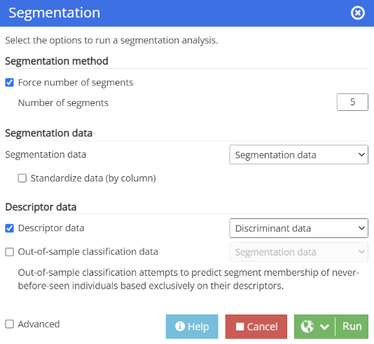
- 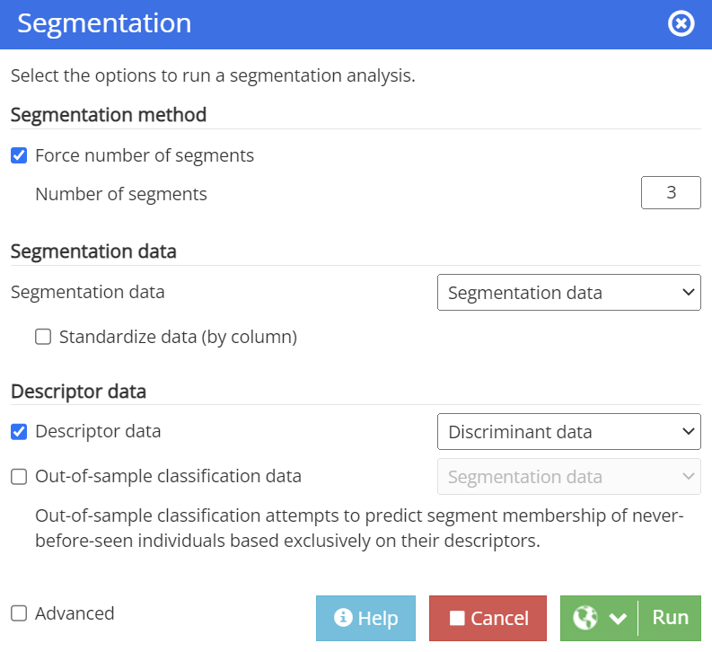

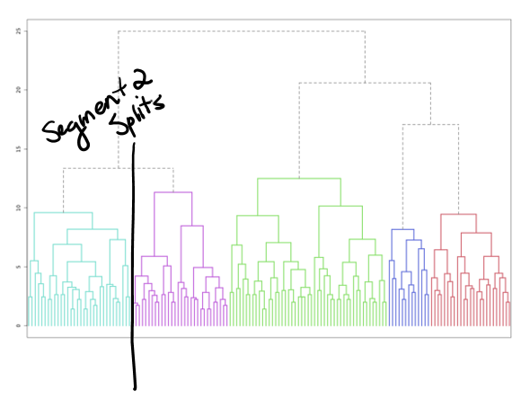
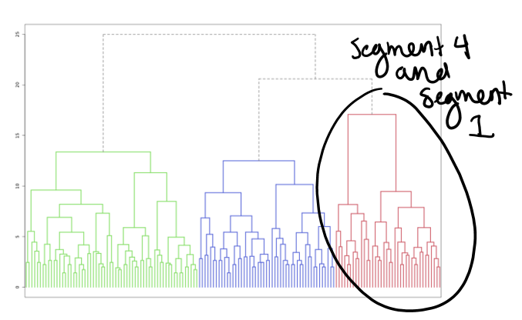

Initial segments 1 and 4 are combined when forcing the solution with one less segment. Initial segment 2 split apart when forcing the solution with one more segment.

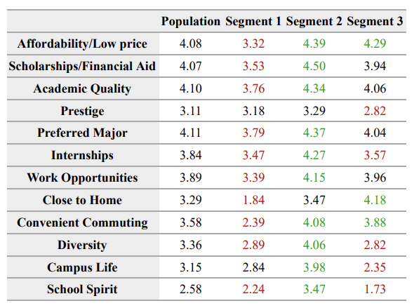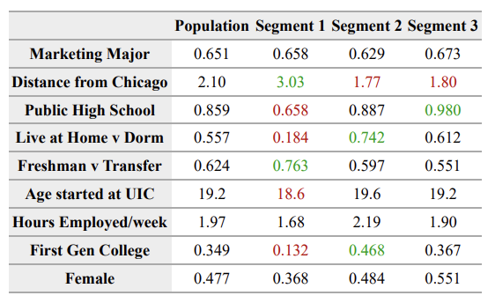
Segment 1 looks entirely different in the 3 segment model versus the 4 segment model; Prestige no longer becomes a significant variable, and Academic Quality, Preferred Major, Internships, Work Opportunities, Diversity, and School Spirit become statistically significant below the average. The relative size of segment one goes up from 17% to 26% when going from the 4 segment model to the 3 segment model. The significant change reveals that the prestige distinction gets lost in the 3 segment model.
Between the 3 and 4 segment model, there are minor differences in the descriptor variables. Segment 1 still has segmentation variables: Distance from Chicago and Freshman v Transfer is statistically significant above the average, and Public High School, Live at Home v Dorm, and First Gen College are statistically significant below the average. The difference lies in the variable Age started at UIC, which has significance below the average in the 3 segment model but not in the 4 segment model. We are still looking at higher-income household students who went to private schools, transferred or worked before coming to UIC, and aren’t first gen students—but looking at a demographic of students who are now coming to UIC starting at a younger age.
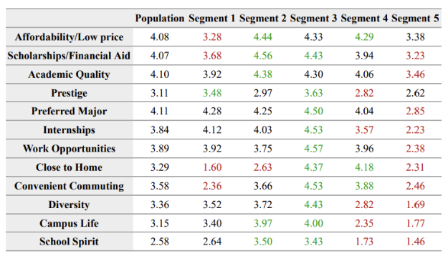
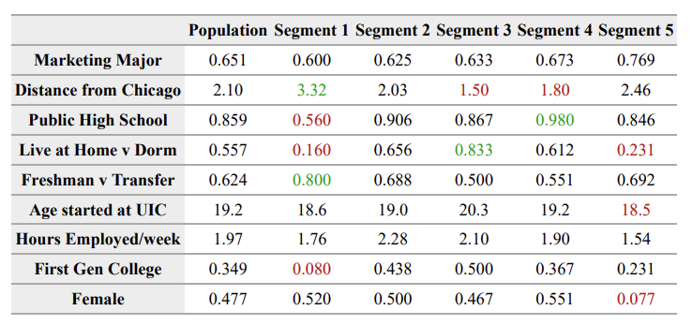
In the 5 segment model, segment 2 has the segmentation variable Close to Home statistically significant below the average, and Preferred Major, Internships, Work Opportunities, Convenient Commuting, and Diversity statistically insignificant. Segment 3 has segmentation variables Prestige and Close to Home statistically significant above the average, and Affordability/Low price and Academic Quality statistically insignificant.
With segment two getting split among the five segment model, you gain new insights that weren’t revealed in the four segment model. What is shown is a segment that is more concerned about affordability and cost savings, while being close to home is unimportant. There is also a segment that holds more importance towards prestige and being closer to home, and affordability and academic quality are no longer significant variables.
In the descriptor analysis for the 5 segment model, segment 2 has no descriptor values that hold significance. Segment 3 has descriptor values Distance from Chicago statistically significant below the average and Live at Home v Dorm statistically significant above the average. Segment 3 includes students that lives closer to Chicago and plan to live at home.

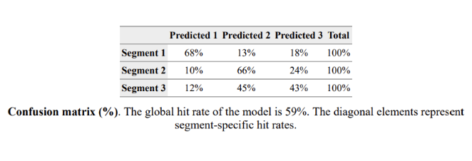
3 Segment Global Hit Rate: 59%

4 Segment Global Hit Rate: 58%
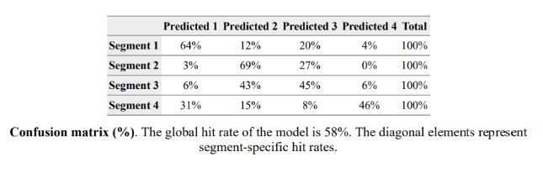

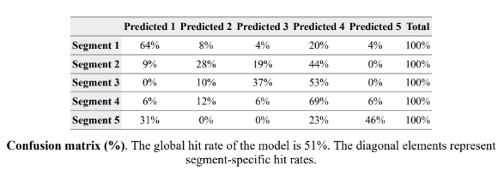
5 Segment Global Hit Rate: 51%

The 3 segment model has the highest global hit rate at 59%; the 4 segment model has the second highest global hit rate at 58%.

With the 3 segment model, you lose the prestige distinction in segment 1 for students who attended private school, transferred or worked before attending UIC, and aren’t first generation students. Given the descriptors of the students in this segment, the prestige distinction is important. It is also essential to separate segment 4 from 1 to avoid pooling students who aren’t needs-based with the prestige segment for better targeting. With the 5 segment model, there aren’t any significant descriptor values for segment 2, making it hard to understand and best cater to that segment’s needs thoroughly. While the 3 segment model has the highest global hit rate, it is only by 1%. I recommend the 4 segment model, as it is the best solution for UIC and will help UIC understand which undergrad students to target.

Segment 1: High-End Students
I decided to name segment 1 “High-End Students” because these are your students who come from higher-income families that paid their children to go to private schools and aren’t concerned about affordability, cost, or financial aid. The most important value to this segment is the prestige of the school.
Segment 2: First-Generation Students
I named this segment “First-Generation Students” because these students are your local first-generation students looking to get the most out of their college experience at a lower price. First-gen students are primarily concerned about getting financial assistance while taking full advantage of this opportunity to get a college degree. Segment 2 is UIC’s largest segment, with 62 students, or a relative size of 42%.
Segment 3: Homebodies
The label I chose for segment 3 was “Homebodies” because this segment lives close to Chicago and values a school close to home with convenient commuting options; these students find comfort in being able to attend college while still living at home and being with their families. This segment also values affordability, so another driver for staying at home could be to save money on room and board.
Segment 4: The Indifferent
I labeled this segment “The Indifferent” because no segmentation variables were important when deciding where to go to college; most of the segmentation variables were statistically significant below the average. Affordability/low price and Prestige were not statistically significant. This segment is also predominantly male, lives on campus, and started UIC at a younger age. This segment is UIC’S smallest, with only 13 and a relative size of 9%. The students either had motivations not listed in the survey or were pushed to college by parents/family/society.
I would fall under “Homebodies”: I live in the suburbs of Chicago and knew I wanted to live at home while finishing my college degree. I also don’t drive to school, so I wanted to be able to take the train into the city and commute to class.

The Dean of the UIC business school should target segments 2 and 3—these two segments are UIC’s largest, with 62 and 49 students with relative sizes of 42% and 33%, respectively. Given that segment 4 is so small, and no values motivate this segment to pick a school, UIC should avoid targeting segment 4. Segment 1 is also significantly smaller than 2 and 3, with only 25 students; It could also be challenging to compete with schools like Northwestern and the University of Chicago on prestige. UIC should focus on affordability, convenient commuting, and guidance for First-Gen students in its marketing messages. UIC can appeal to these segments by focusing on having a low-cost value proposition. The UIC Business School can also run similar programs to their current offering, “Commuter Appreciation Week.” In addition, UIC can offer panel discussions, workshops for internships, and career advice for First-Gen students.

The segmentation tool is beneficial in this scenario because it gives UIC better information about the school’s strengths and what ultimately made students choose UIC. The segmentation tool also allows UIC to cluster its students into groups based on similar needs and wants, helping UIC determine what students to serve and how to attract them. Through the segmentation tool, UIC can provide greater value for targeted segments, increasing market share profitability for the school.
All students in the sample chose to attend UIC, and the majority are marketing majors. The sample does not represent all UIC undergrads or students that considered UIC but decided to attend another school. All students chose to go to UIC, so their answers are biased toward UIC. UIC could benefit from gaining insight from students who didn’t ultimately choose UIC or are across different majors, adjusting its marketing to better appeal to those segments, or adjusting the school’s offerings to fit those students’ needs better. UIC is missing out on this valuable information.

