GOOGLE ANALYTICS 4 WORKSHOP

ACCESS DEMO ACCOUNT with your Google Account in the link below
https://support.google.com/analytics/answer/6367342?hl=en

PART 1
You are the digital marketing manager for Google Merchandise. There is a website portal as below for selling Google merchandise products. The website you are tracking is :
https://shop.googlemerchandisestore.com

You are required to answer the questions below using Google Analytics 4 demo account for the website. Ensure you select the Store for the demo account as shown below

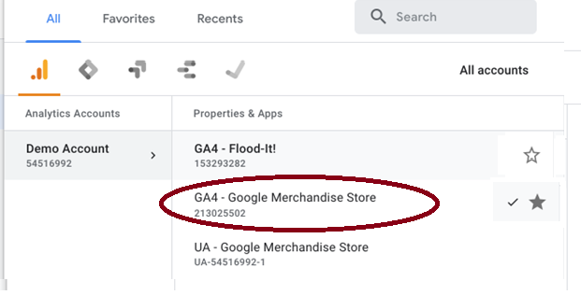

HOME
- Use Home Page to find answers to the below :
  - How many active users are there right NOW?
    - Answer : 18k
REPORTS Page
Look at Reports Report Snapshot
- Change the Timeframe to the last 3 months and find answers to below

  - Which webpage got the maximum number of views?
    - Answer : Home – 252k views

  - Which event created the maximum conversions?
    - Answer : first_visit – 191k

  - Which is the top selling product?
    - Answer : Google Unisex Eco Tee Black - 571

Look at Reports LifecycleAcquisition

  - Which source did most new users come from in the last 3 months?
    - Answer : Organic Search

  - Drilling more into this, what is the “Average Engagement time per session” for organic search
    - Answer : 2m 9s

  - What is the LifetimeValue for users in the last 3 months?
    - Answer : $1.71

Look at Reports LifecycleEngagement

- What is the total reported Event Count?
    - Answer : 9.1M

- Create Comparison for Users in United States vs India for Engagement. Which country users had more engagement on the website? Provide the Average Engagement time for the users of each country.
    - Answer : United States (US: 2m 46s, India: 1m 03s)

Look at Reports LifecycleMonetization

- What is the total revenue for all users in the website ? Give details on how it is calculated and provide the revenue amount?
    - Answer : Total revenue is 752k [calulcated: The sum of revenue from purchases, subscriptions, and advertising (Purchase revenue plus Subscription revenue plus Ad revenue)]

- What is the average purchase revenue per user for “Purchasers” vs “ Engaged Users” (For this, Use comparison for Dimension of Audience Name)
    - Answer : Purchasers: $93.74 Engaged Users: $10.55
Look at Reports LifecycleRetention
- How many Returning users are there among “Purchasers” in the last 3 months? (For this, Use comparison for Dimension of Audience Name)
    - Answer : 30 users

Look at Explorations
- Create a Funnel Exploration.
  - What is the abandonment rate for “First open/visit” step?
    - Answer : 63%

PART 2

You have been hired as a digital marketing analyst for Flood It!. Flood It! is a real puzzle game in which you have to flood the whole game board with one color in fewer than the allowed steps. Flood It! has Google Analytics 4 implemented. The mobile app data is flowing to the Google Analytics 4 demo project. The data available is typical of what you might see for a gaming app with in-app purchases.

Step 1
Use the GA4 demo account as we have learned. Make sure when you access the demo account you navigate to the Property ‘GA4 - Flood-It!’ (see images below).

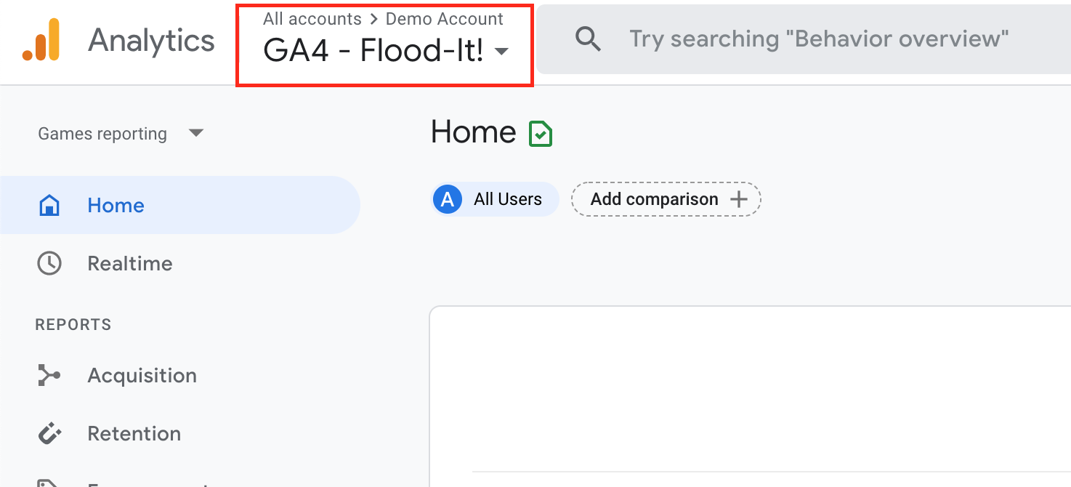

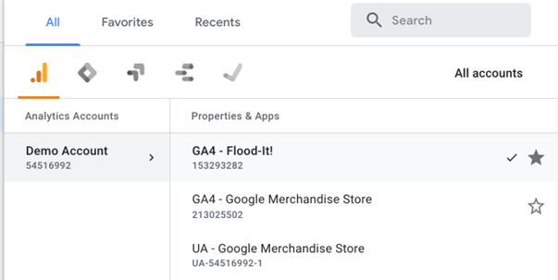

Step 2
Your manager is interested in the mobile app performance for Flood It! for the last 30 days. When you open the Google Analytics 4 analytics dashboard, make sure you adjust the date filter in the upper right-hand corner to get the required dates. Your manager has asked you to answer the following questions using data from the Google Analytics 4 demo account.

1. How many new users did the Flood It! mobile app have?

36k users.

2. How many new users were acquired through paid search?

2k users.

3. How many returning users did the Flood It! mobile app have?

30k users.

4. How many post_score events occurred?

170k.

5. In minutes and seconds, what was the average engagement time?

8m, 09s.
6. Which event name had the highest count?
Screen_view – 2.2M

7. What was the total revenue?
$18.31

8. Flood It! uses an audience called “Crashing Users” to track users that experienced an app crash. How many “Crashing Users” were there?

658 users.

