Kyra Kroll
MKTG 467
Professor Razi
2/20/2022
ASSIGNMENT 2: SQL

Table: Suppliers (1-4)

- Select Distinct

SQL Statement:
SELECT DISTINCT SupplierName FROM Suppliers;
Result Image:
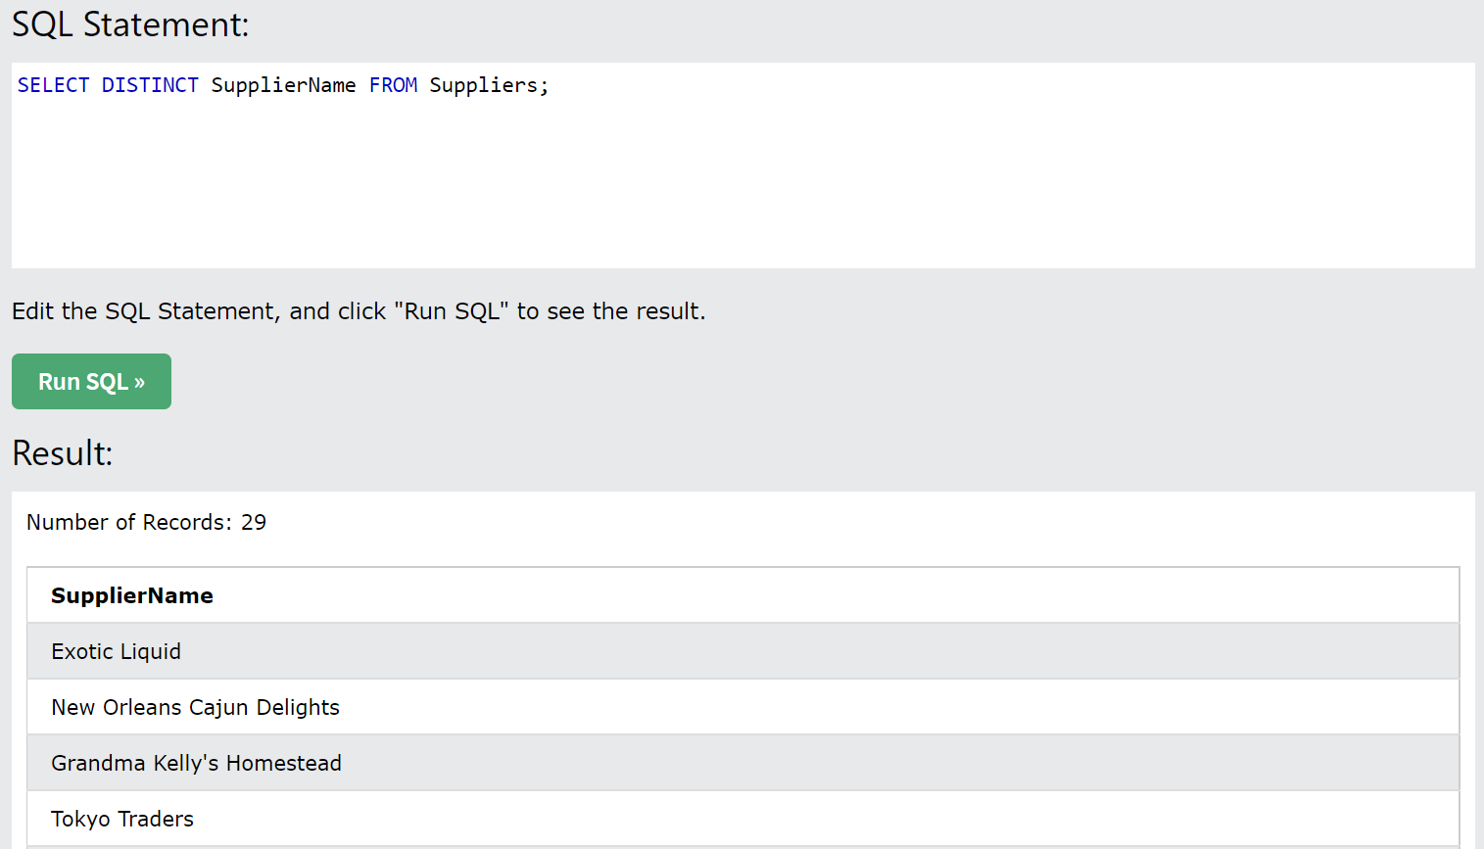
Marketing Question:
Get distinct records for Supplier Names from Suppliers table.

- Select Where

SQL Statement:
SELECT * FROM Suppliers
WHERE City = ‘Tokyo’;
Result Image:
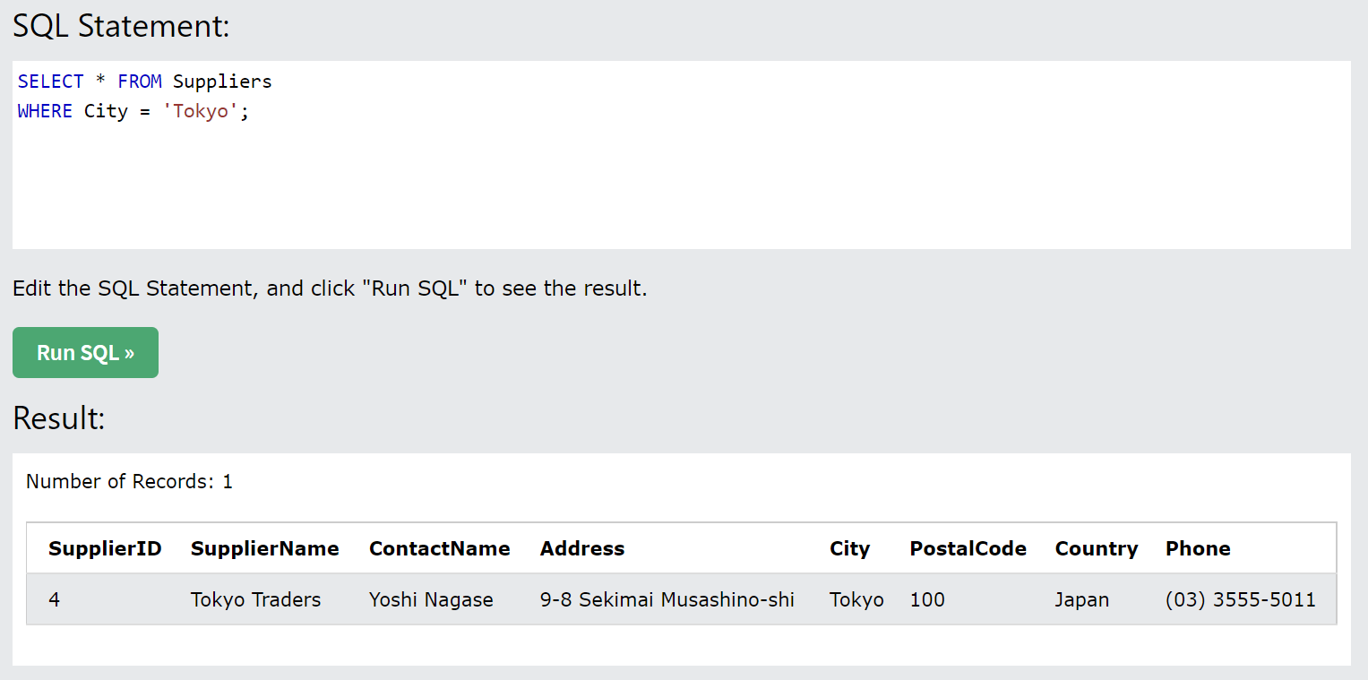
Marketing Question:
Get Suppliers from Tokyo city.

- Select WHERE (along with use of AND/OR/NOT)

SQL Statement:
SELECT * FROM Suppliers
WHERE SupplierName LIKE "P%" AND (Country= 'Australia' OR Country= 'Sweden');
Result Image:
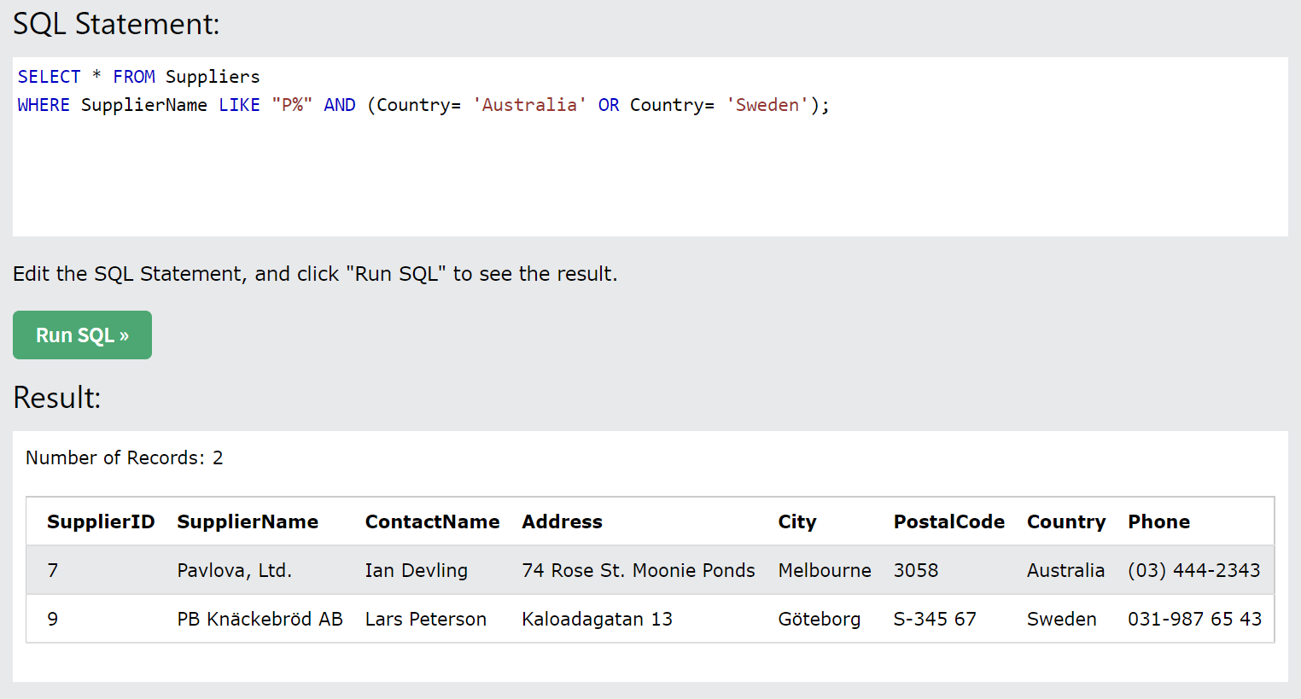
Marketing Question:
Get Suppliers whose name starts with “P” and are from Australia or Sweden.

- Select Where (along with the use of Order By)

SQL Statement:
SELECT * FROM Suppliers
WHERE Country = 'Germany'
ORDER BY SupplierName DESC;
Result Image:
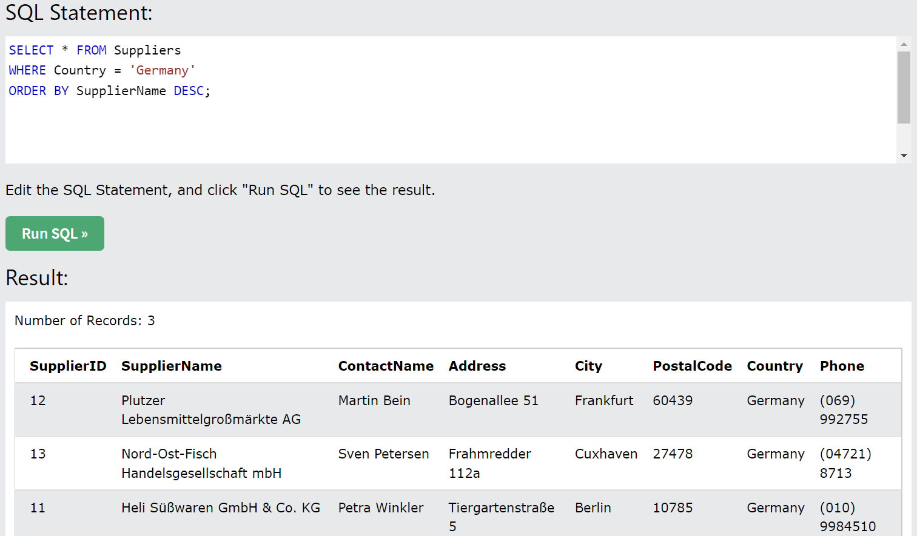
Marketing question:
Get Supplier Names from Germany. Show them in descending order.

Table: Products

- Select Count/Avg/Sum along with GroupBy

SQL Statement:
SELECT SUM(Price), SupplierID
FROM Products
GROUP BY SupplierID;
Result Image:
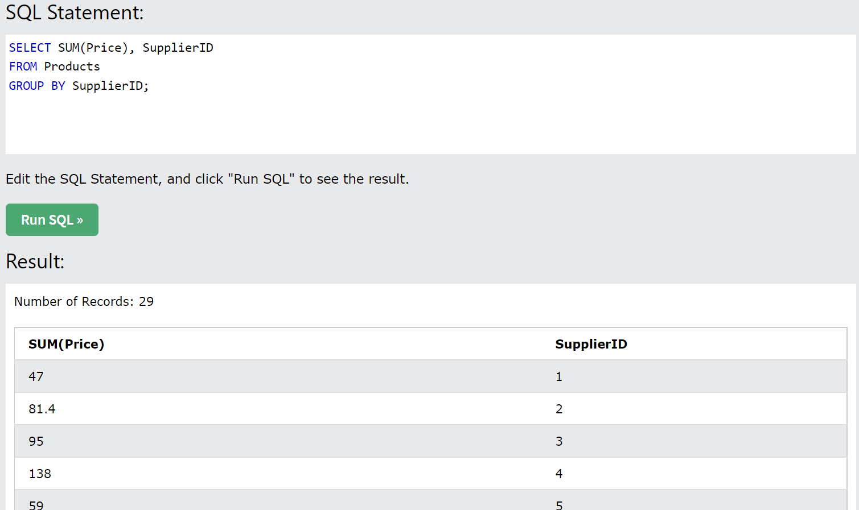
Marketing Question:
Get the sum of Prices charged by each Supplier. Group By SupplierID.

Table: OrderDetails

- Select MIN/MAX

SQL Statement
SELECT MAX(Quantity) AS LargestQuantity
FROM OrderDetails;
Result Image:
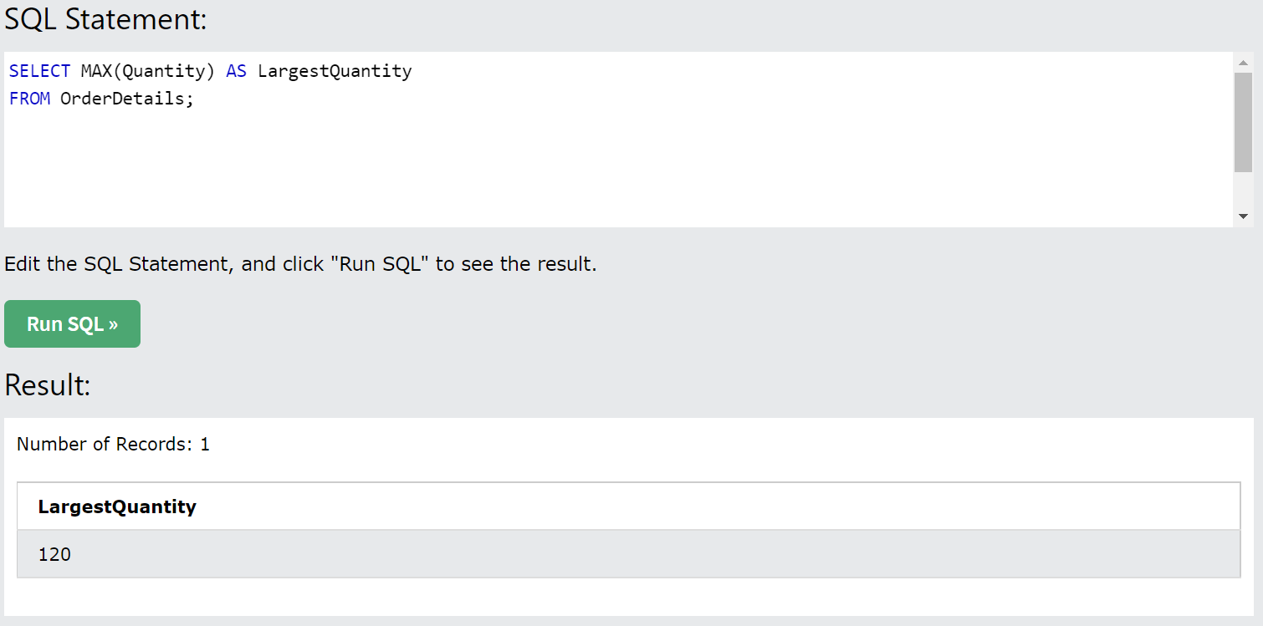
Marketing Question:
Get the largest Quantity of orders from Order Details.

Table: Suppliers

- Select WHERE (with usage of LIKE)

SQL Statement:
SELECT * FROM Suppliers
WHERE ContactName LIKE ‘C%’;
Result Image:
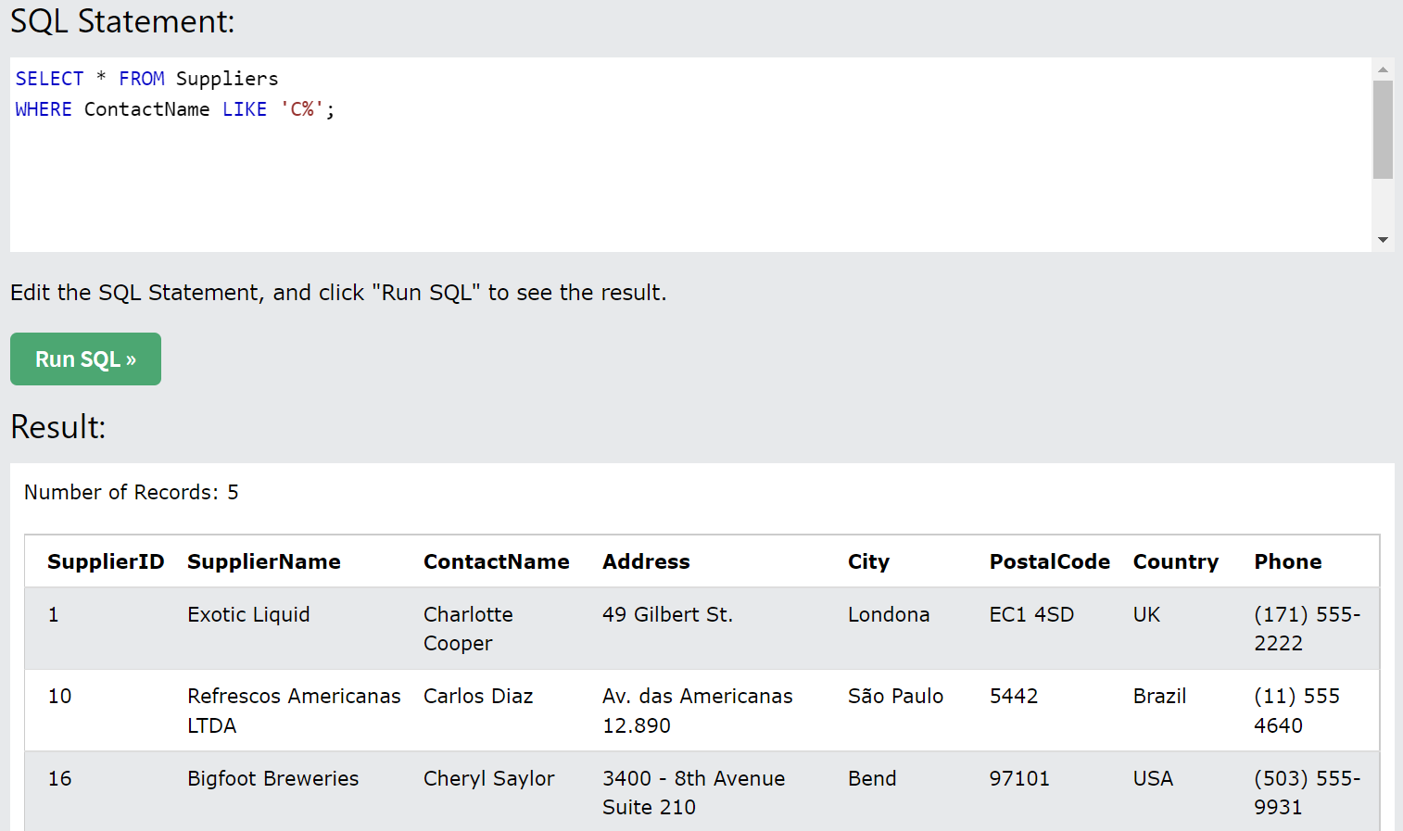
Marketing Question:
Get Contacts from Suppliers whose names start with “C”.

Tables: Customers and Products

- Select Join (along with the use of AND/OR/NOT)

SQL Statement:
SELECT Customers.CustomerName, Products.ProductName
FROM Customers
INNER JOIN Products
ON Customers.CustomerID= Products.ProductID
WHERE ProductName = 'Tofu' OR ProductName = 'Chang';
Result Image:
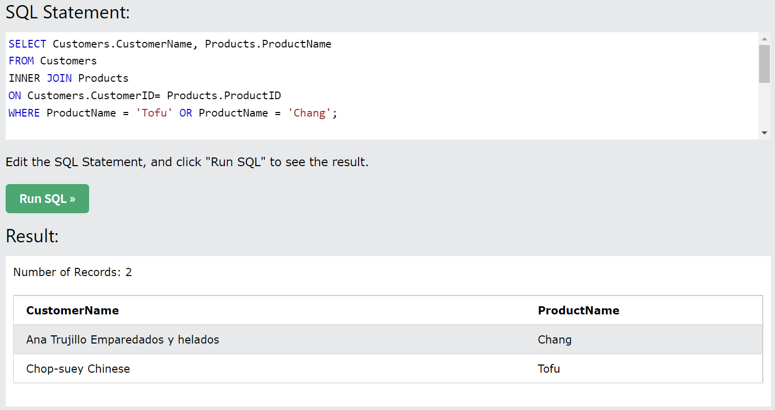
Marketing Question:
Get the names of the Customers who ordered Chang or Tofu.

Tables: Products and Categories

- Select Join (along with use of Group By)

SQL Statement:
SELECT Products.ProductName, Categories.CategoryName
FROM Products
LEFT JOIN Categories ON Products.ProductID=Categories.CategoryID
GROUP BY ProductName;
Result Image:
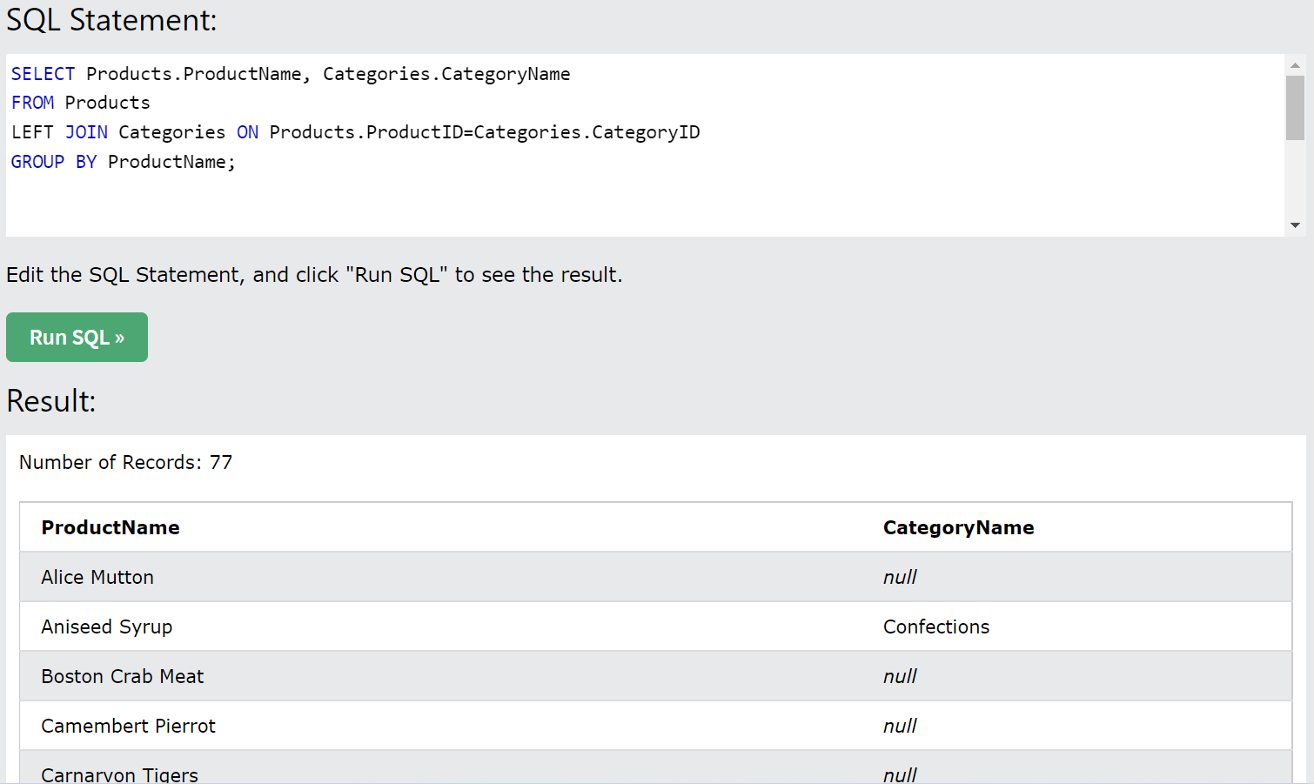
Marketing Question:
Get Products that got assigned a Category Name and Products that did not. Group by Product Name.

Tables: Customers and Orders

- Select Union

SQL Statement:
SELECT CustomerID FROM Customers
UNION ALL
SELECT CustomerID FROM Orders
ORDER BY CustomerID;
Result Image:
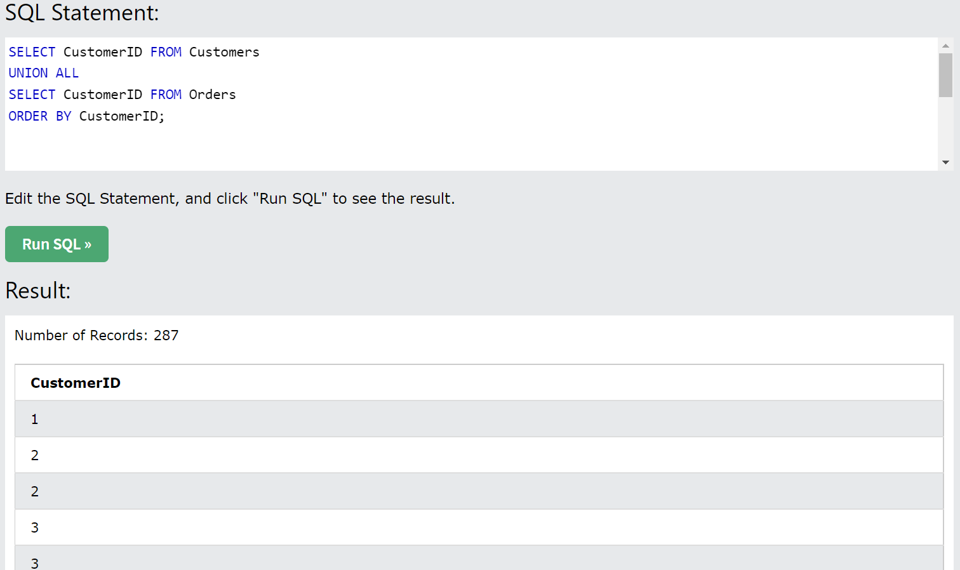
Marketing Question:
Get a combination of Customer IDs from Customers and Orders. Order by CustomerID.

