MKTG 460 FINAL EXAM – PART B

- 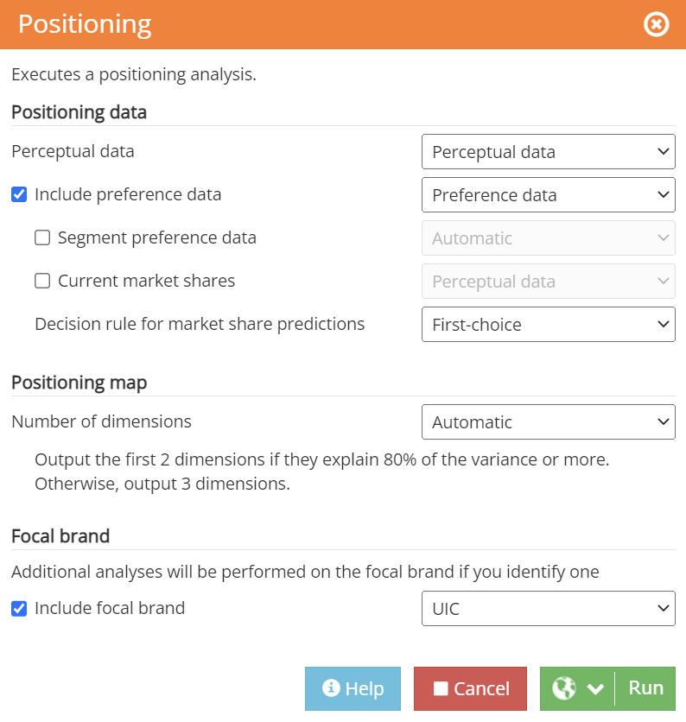

The number of dimensions automatically selected by the software is 2, since the first two dimensions explain more than 80% of the variance in the data (85%, to be specific).
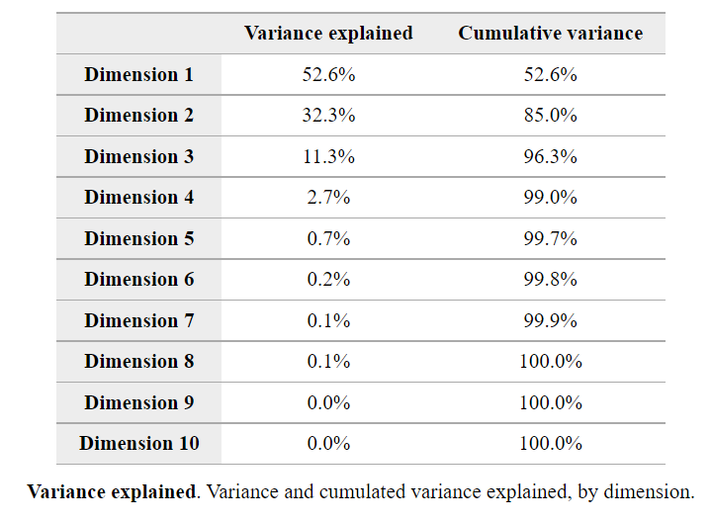
Dimension 1 explains 52.6% of the variance, while Dimension 2 explains 32.3%, making Dimension 1 more important.

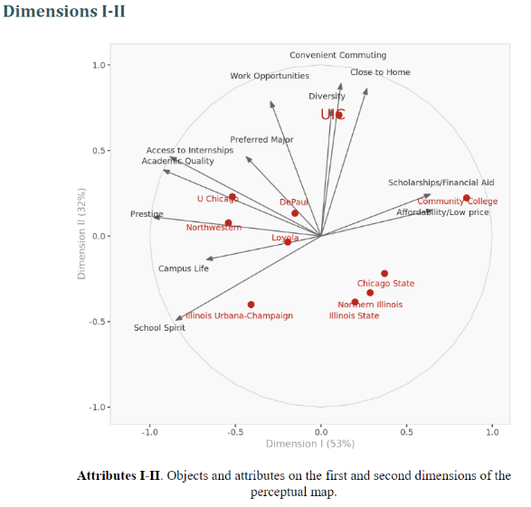
- 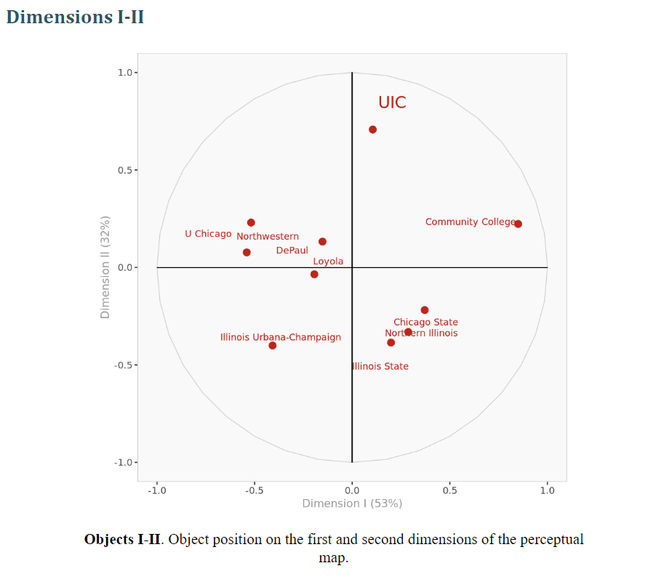

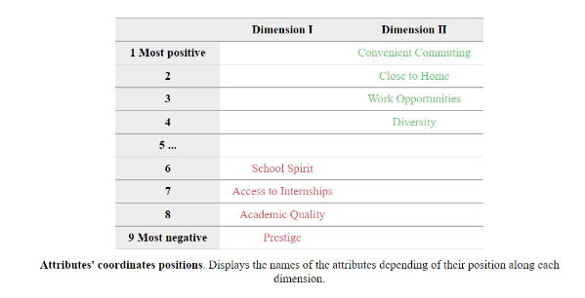
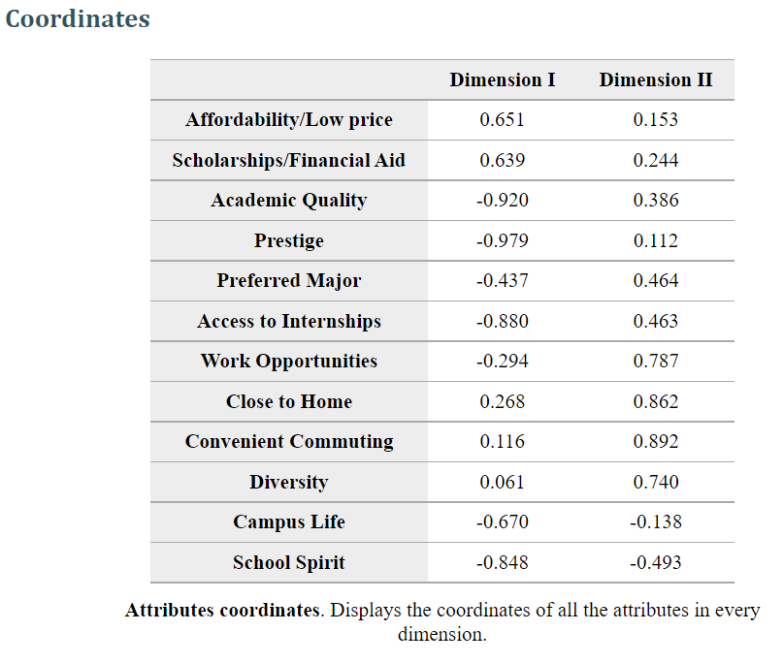

Dimensions represent categories in which customers perceive products or services and views of company offerings relative to competitive offerings; the dimensions characterize how customers differentiate among these alternatives.

X-AXIS/DIMENSION 1: ELITISM - AFFORDABILITY
Dimension 1 attributes on the left side of the axis are related to school "elitism," or how schools are perceived in terms of their academics, prestige, school spirit, and connections to internships. School spirit is typically connected to athletics and funding; schools with higher-level teams that generate revenue will have more school spirit. When schools are perceived highly on these attributes, they are usually high-ranked, well-known, and costly; students are willing to pay and travel the distance to attend these schools.
On the right side of the axis, attributes are related to "affordability" or how schools are perceived based on their financial resources (scholarships/financial aid, affordability/low price). Students choose these schools because they are less costly.
Y-AXIS/DIMENSION 2: COMFORT/EASE
Dimension 2 measures a school's ability to bring comfort and ease to its students based on how it is perceived on its closeness to home, convenient commuting options, diversity, and work opportunities. Diverse and local schools are inclusive to students, allowing them to experience college while having the chance to stay at home. These schools provide a sense of familiarity and togetherness.

- 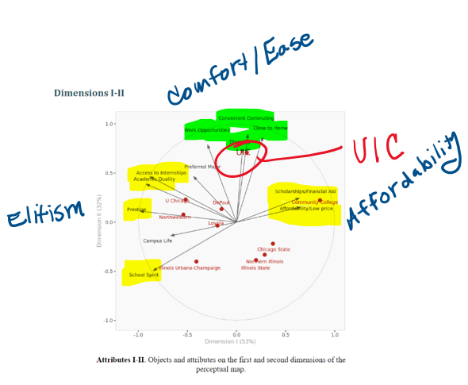

UIC's strongest attributes are Work Opportunities, Convenient Commuting, Closer to Home, and Diversity. UIC is on Dimension 2, meaning that it is not perceived as a school that is either elite or affordable (Dimension 1) to consumers and falls weak on those attributes: School Spirit, Prestige, Academic Quality, Access to Internships, Scholarships/Financial Aid, and Affordability/Low Price.

- 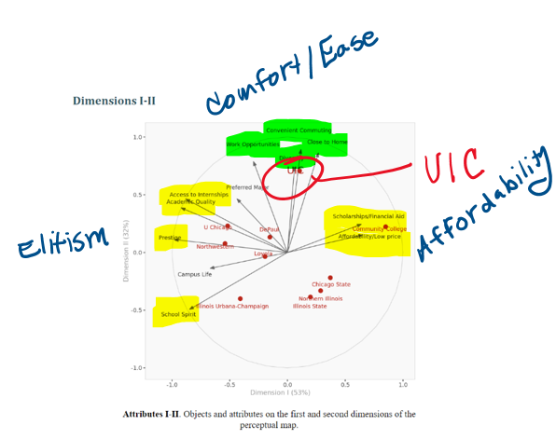

The school in closest competition with UIC is DePaul. The schools not competing with UIC are U Chicago, Northwestern, Illinois Urbana-Champaign, Northern Illinois, Illinois State, Chicago State, and Community College since they are perceived on different dimensions and/or are not near UIC on the perceptual map. While Loyola does not appear to be a direct threat to UIC, UIC should still consider Loyola as a potential competitor.
U Chicago and Northwestern appear to be very similar to one another and are close competitors. DePaul and Loyola also appear to be close competitors to each other. Chicago State, Northern Illinois, and Illinois State are also close to one another on the perceptual map and are close competitors.
With UIC being the only school perceived high on Dimension 2, it appears that UIC has established a unique position in the market, differentiated based on comfort and ease, offering convenient commuting, diversity, and work opportunities, while being close to home.

- 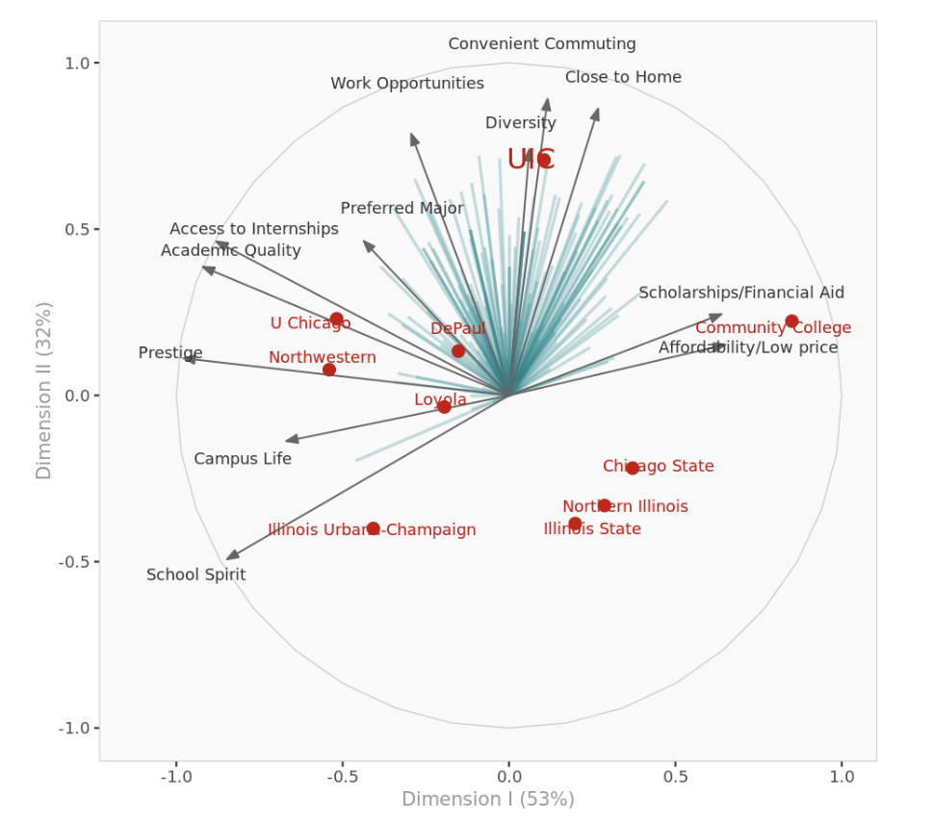

UIC is in the best position to satisfy the preferences of the 148 survey respondents, with DePaul showing potential. University of Illinois Urbana-Champaign, Illinois State, Northern Illinois, and Chicago State are nowhere near these preferences. U Chicago, Northwestern, Loyola, and Community College are in proximity but aren't optimally positioned.
The survey consists of 148 undergraduate students taking a marketing course at UIC; they were asked to rate UIC and its competitors in Chicago and Illinois. While they were asked to rate how strongly they considered attending each school when first applying, they ultimately chose UIC. With the survey only consisting of business students that chose UIC, there is a lack of diversity in the sample. UIC could appear exceptionally high in the "average brand preference" because of bias.

- 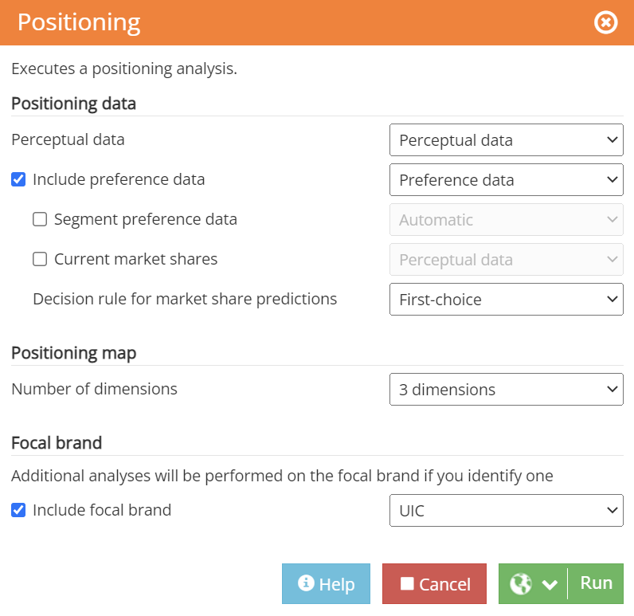

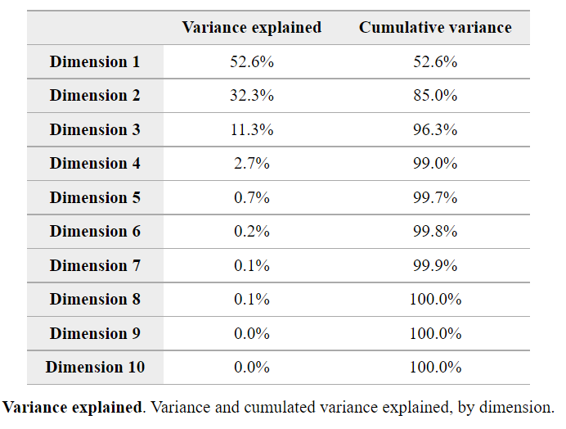
Dimension 3 explains an additional 11.3% variance, increasing the cumulative variance to 96.3%.
DIMENSION 1:
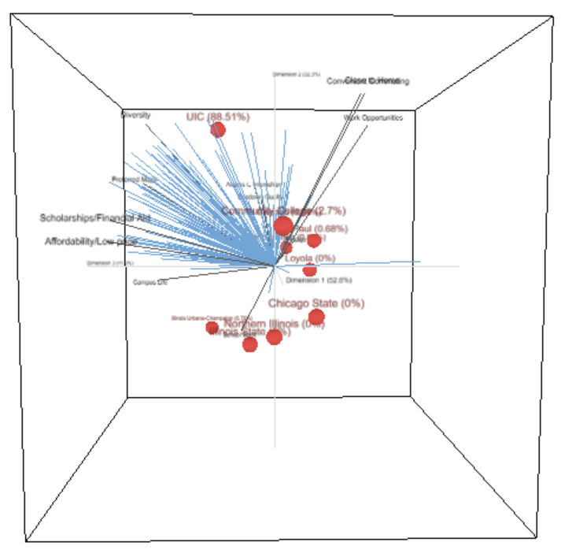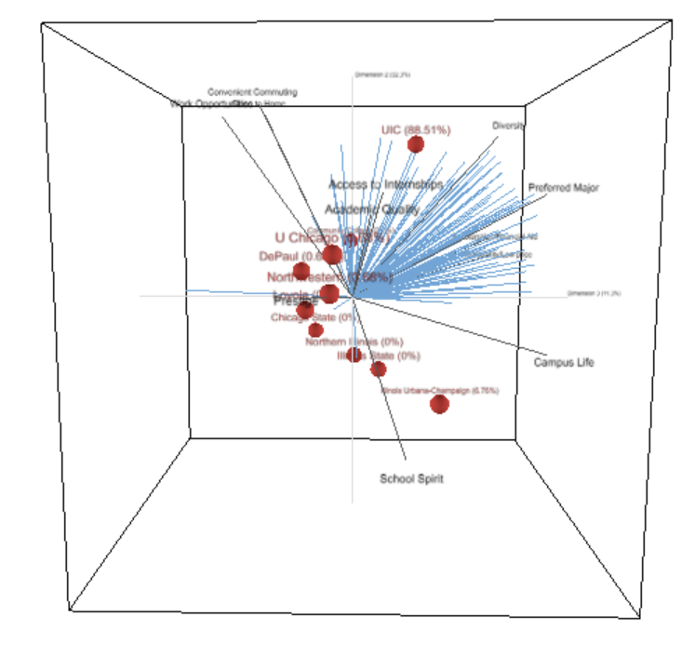
DIMENSION 2:
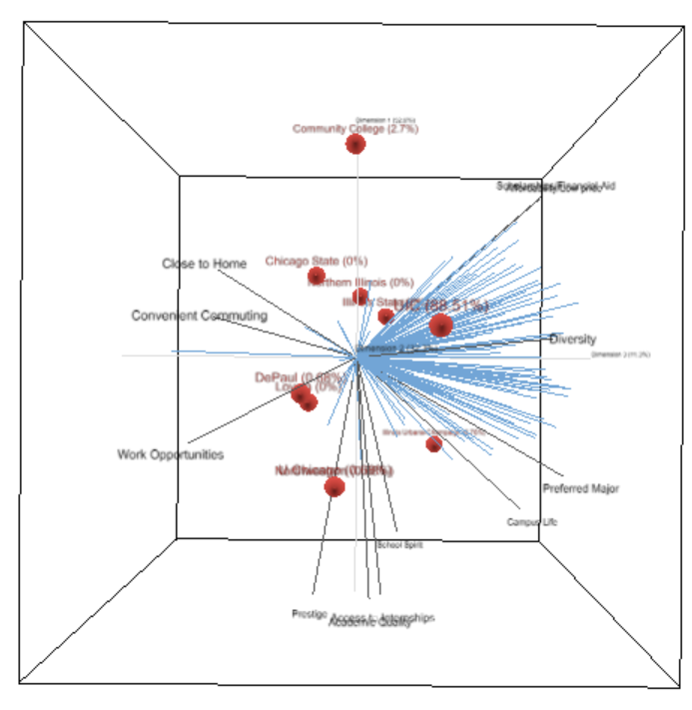
DIMENSION 3:
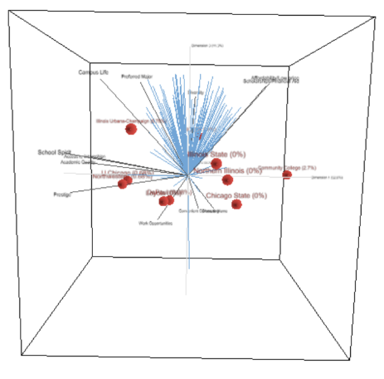
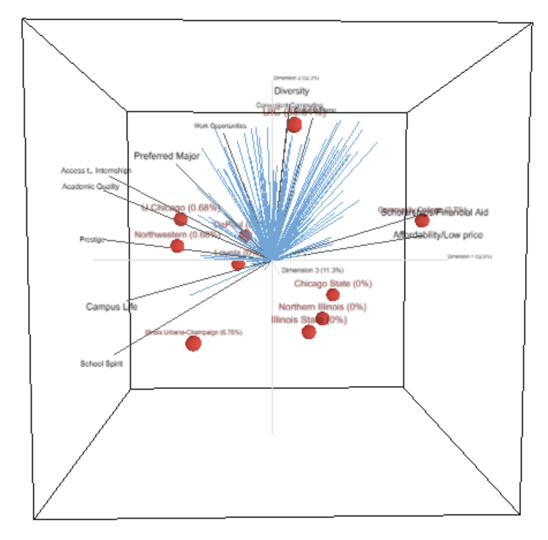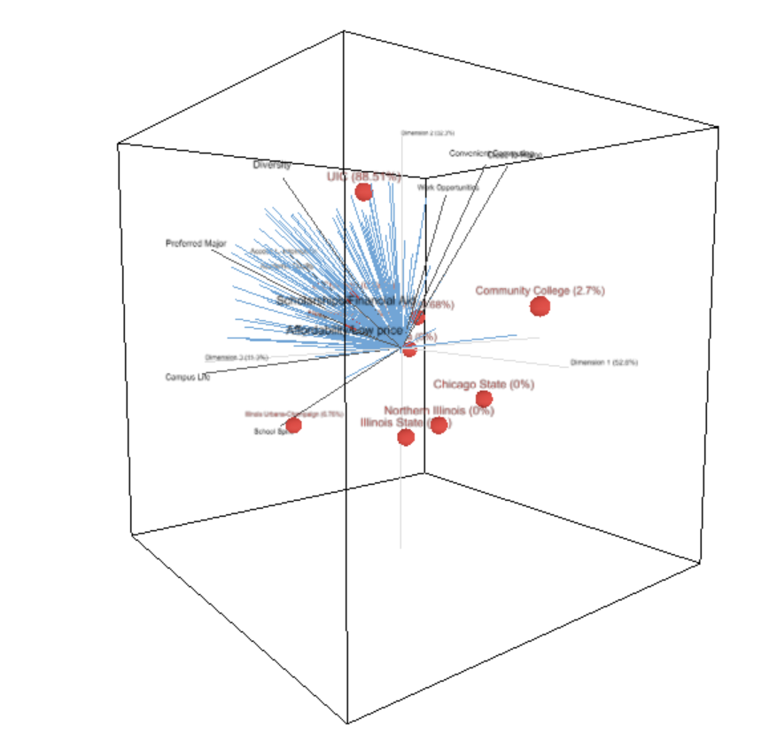

With the 3 Dimension model, some new insights emerge that were not visible in the first two dimensions; UIC is not directly aligned with the vector attribute Diversity or Convenient Commuting, and Diversity is the only attribute vector from Dimension 2 that aligns with preferences. Contrary to the 2 Dimension analysis, the 3 Dimension analysis reveals that UIC is not as close to Work Opportunities, Convenient Commuting, or Close to Home. UIC is in the most immediate proximity to the attribute Diversity.
While no attribute vectors are directly on Dimension 3, the ones closest are Diversity, Campus Life, Preferred Major, Scholarships/Financial Aid, and Affordability/Low Price. Based on these attributes, I would label Dimension 3 "Accessibility"; Dimension 3 represents schools that are perceived based on their level of accessibility. Universities perceived high on this dimension are inclusive/diverse, offer majors that students need, give students a chance to interact socially, and are within budget.

- 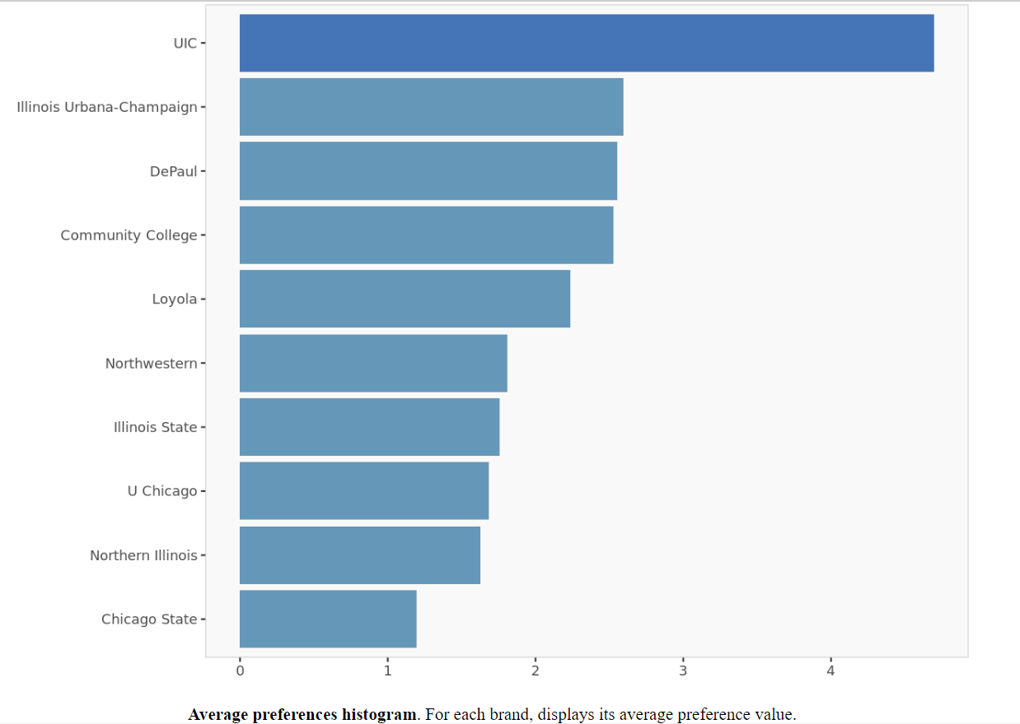

The current positioning for UIC students is ideal, especially compared to competitors, as UIC is the only university aligned with the preferences of undergraduate business students and has the highest average preference value. When exploring the different positioning options, I increased UIC's market share from 88.51% to 97.3% by improving Diversity from 4.4 to 5.00, Preferred Major from 4.32 to 5.00, and Campus Life from 3.3 to 3.98. UIC's strengths as a university are its work opportunities, convenient commuting options, preferred majors, and diversity. UIC can strengthen its positioning by focusing on attributes Diversity, Preferred Major, and Campus Life.
Rather than focusing on the attributes from Dimension 1 (elitism and affordability), UIC should focus more on being an accessible school that ignites feelings of comfort and ease to obtain a differentiated position. UIC can actively set and reach diversity goals (admissions/attendance percentages) and provide opportunities exclusively for BIPOC students to develop professionally. UIC can create a DE&I program, partnering with local businesses to conduct marketing workshops where students can learn marketing skills in new industries and network. UIC can also incorporate more theme night activations and promotions for sporting events to improve campus life and run more social events (like the UIC SPARK concert). What makes UIC an excellent choice as a university is its number and variety of concentrations. Make this attribute more widely known in UIC's marketing messages and use course evaluations to pick students' brains, understand their needs, and create new courses and majors that fit those needs.

